Our Changing World (Listening): Unit standard 15007

Writers: Jenni Bedford and Breda Matthews

NCEA LEVEL 2
Unit standard | Elements and performance criteria
Unit standard 15007, version 5  Understand spoken information and instructions in familiar contexts (ESOL) | Element 1: Understand spoken information in familiar contexts (ESOL).  Range: Three types of spoken texts.  Performance criteria  1.1 The purpose of the spoken text is  identified.  1.2 Specific information in the spoken  text is identified.  Range: At least three pieces of information  for each text.  Element 2  Follow multi-step spoken instructions in familiar contexts.  Range: Two different contexts, each with  three multi-step instructions.  Performance criteria  2.1 Tasks are completed according to  instructions.

RESOURCES

Assessment activities, for other unit standards, that could be used in conjunction with unit standard 15007.
- Speaking: ‘Our Changing World’ (unit standard17360)
- Reading: ‘Our Changing World’ (unit standard 2986)
- Writing: ‘Our Changing World’ (unit standard17368)
Teacher sheet

Unit standard 15007, version 5
Understand spoken information and instructions in familiar contexts (ESOL)
Level 2 4 credits
This unit standard has two elements.

Element 1: Understand spoken information in familiar contexts.
Range: Three types of spoken text.

Element 2: Follow multi-step spoken instructions in familiar contexts.
Range: Two different contexts, each with three multi-step instructions.
Conditions
- All assessment activities must be conducted in English, which must not be the student’s first language.
- Texts may be repeated once only.
- Texts must contain information that is relevant to the students.
- Texts may be presented face-to-face or electronically.
- Texts must be appropriate to the spoken mode or a text which is designed for oral delivery.
- Student evidence for this assessment may be oral or written. However, responses must not be heard or observed by other students.
- Responses must be given without prompting.
- Where written assessment tasks are used, students must be given the time to read and seek clarification of the questions before the listening task begins.
- Students should be given time at the end of the assessment to check their answers.
- Written responses do not have to be grammatically correct although errors must not interfere with meaning.

Learning contexts
It is important that topics used for spoken texts are familiar to students. This can be achieved by linking them to writing topics and reading topics. The listening texts for element 1 can model the conversations needed for unit standard 17360.

Notes for Assessors
- It is important that students are familiar with the requirements of the performance criteria and the special notes.
- Refer to your institution’s policies on resubmission and reassessment before offering further assessment opportunities.
- If resubmission takes place, the assessor should ensure that the correct answers are not inadvertently indicated when the scripts from the initial assessment are returned. For example, in a true or false exercise, students should redo that part of the assessment on an unmarked copy.

Student instructions: Element 1

Unit standard 15007, version 5
Understand spoken information and instructions in familiar contexts (ESOL)
Level 2 4 credits

Element 1: Understand spoken information in familiar contexts.
Range: Three types of spoken text.
Conditions
- You will be given time to read the questions before you listen to the text.
- You may check anything you don’t understand about the questions before the assessment begins.
- You will hear the text twice.
- Do not ask questions during the spoken text.
- You will be given time at the end of the assessment to check your answers.

Glossary
Text means the spoken words you will listen to.
Identify means to say what something is e.g. The main idea is …….
Recording means an audiotape, video or CD.

Student checklist: Element 1

In this assessment task you will need to show that you can do the following things:
Say what the purpose of the text is e.g. to ask for information. | 1.1
Identify at least three pieces of information in each text by answering questions about what is said in the text. | 1.2

Teacher instructions: Task 1 (Element 1)

Unit standard 15007, version 5
Understand spoken information and instructions in familiar contexts (ESOL).
Level 2 4 credits

Element 1: Understand spoken information in familiar contexts.

- Read the text out loud.
- Allow a couple of minutes before reading the text a second time.
- Allow time for students to complete and/or check their answers.

Listening text: Task 1 (Element 1)

Read the following to your students.

- Find Task 1 and read the questions.
- Now listen to the text and answer the questions.

Kyu-Jin:  Mrs Chen:  Kyu-Jin:  Sam:  Kyu-Jin:  Sam:  Kyu-Jin:  Sam:  Kyu-Jin:  Sam:  Kyu-Jin:  Sam: | Hi Mrs Chen. This is Kyu-Jin. I’m sorry to phone so late but can I  speak to Sam, please?  That’s okay, Kyu-Jin, Sam’s right here. I’ll get him for you.  Hi Sam. We’ve got to meet so that we can work on our science  homework. When are you free?  I’m at basket ball practice tomorrow. What about Thursday after school?  No, I’ve got soccer practice on Thursday. Can you make it on  Saturday?  Yes, Saturday’s good. What about meeting at my house so we  can use the computer for our poster?  Good idea. What time?  What about 10 o’clock? I don’t like getting up too early at the weekend!  10 is fine with me too. Now where do you live and how do I get there?  24 Smith Road. It’s the street opposite the petrol station, Smith Road. My house is the last house on the right, number 24.  Okay, that’s 10 o’clock on Saturday morning at your house. See you then.  Bye.

3. Now check your answers.
Student sheet: Assessment task 1 (Element 1)

Unit standard 15007, version 5
Understand spoken information and instructions in familiar contexts (ESOL)
Level 2 4 credits

Name ……………………………………………………. Date …………………..

Element 1: Understand spoken information in familiar contexts.

- You will hear the text twice.
- Listen carefully and answer the questions while you listen.
- Check your answers.

Task 1

1. The purpose of the spoken text is identified (1.1)

What is the purpose of this text? Circle ONE answer.

The purpose of this text is:

a. to give information.
b. to arrange a meeting to do their homework.
c. to find out where Sam is.
d. to check the answers to their homework.

2. Specific information in the spoken text is identified (1.2)
Answer the questions below

a. Why do Kyu-Jin and Sam need to meet?

…………………………………………………………………………………………

b. Why can’t Kyu-Jin meet on Thursday?

…………………………………………………………………………………………

c. What day are they going to meet?

…………………………………………………………………………………………

d. Where are they going to meet?

………………………………………………………………………………………
Teacher instructions: Task 2 (Element 1)

Unit standard 15007, version 5
Understand spoken information and instructions in familiar contexts (ESOL)
Level 2 4 credits

Element 1: Understand spoken information in familiar contexts.

- Read the text out loud.
- Allow a couple of minutes before reading the text a second time.
- Allow time for students to complete and/or check their answers.

Listening text: Task 2 (Element 1)

Read the following to your students.

- Find Task 2 and read the questions.
- Now listen to the text and answer the questions.

Good morning class. Could everyone sit down please. You do not need your text books today.

We have been studying estuaries. In today’s lesson we will look more closely at water and do an experiment.

When fresh water from rivers goes into an estuary, it mixes with salt water from the sea.

Different types of water have different densities. Salt water is denser than fresh water. Cold water is denser than hot water. When two types of water with different densities meet they form layers.

Our experiment will look at what happens when waters with two different types of density meet.

Now find a partner to work with today and come and get a materials list.

3. Now check your answers.
Student sheet: Assessment task 2 (Element 1)

Unit standard 15007, version 5
Understand spoken information and instructions in familiar contexts (ESOL)
Level 2 4 credits

Name ……………………………………………………. Date …………………..

Element 1: Understand spoken information in familiar contexts.

- You will hear the text twice.
- Listen carefully and answer the questions while you listen.
- Check your answers.

Task 2

1. The purpose of the spoken text is identified (1.1)

What is the purpose of this text? Circle ONE answer.

The purpose of this text is:

a. to introduce this year’s course and topics.
b. to remind the class what they did in the last lesson.
c. to give information about the exam.
d. to tell the class about today’s lesson.

2. Specific information in the spoken text is identified (1.2)
Answer the questions below.

a. What topic have the students been studying?

…………………………………………………………………………………………

b. What are they going to do today?

………………………………………………………………………………………..

c. What happens when two different types of water meet?

…………………………………………………………………………………………

d. Write down one thing the students have to do.

………………………………………………………………………………………
Teacher instructions: Task 3 (Element 1)

Unit standard 15007, version 5
Understand spoken information and instructions in familiar contexts (ESOL)
Level 2 4 credits

Element 1: Understand spoken information in familiar contexts.

- Read the text out loud.
- Allow a couple of minutes before reading the text a second time.
- Allow time for students to complete and/or check their answers.

Listening text: Task 3 (Element 1)

Read the following to your students.

- Find Task 3 and read the questions.
- Now listen to the text and answer the questions.

Sam: Hi, Kyu-Jin. Come on in. How are you?
Kyu-Jin: I’m fine, thanks. Have you been busy? I seem to have lots of
homework at the moment.
Sam: No, I’ve only got this project to do but my dad has been working
hard and I’ve had to do lots of extra jobs in the house.
Kyu-Jin: That’s bad. I’m really lucky, my parents never ask me to do
anything in the house. Will your dad have to work this hard for
much longer?
Sam: I hope not! Shall we get started on the project?
Kyu-Jin: Good idea. Now, what did you find out about lugworms?
Sam: I researched physical characteristics and I found a good diagram
that we could use on our poster. What did you find out about
different types of lugworms?
Kyu-Jin: It was a lot of work! There are lots of different types of lugworms
but there are three main groups; burrowers, filter feeders and
predators.
Sam: Did you say predators? Does that mean they eat animals?
Kyu-Jin: Yes, it does, and they live in lots of different places.
Sam: Okay, it looks like we have lots of information, so let’s get started.

3. Now check your answers.
Student sheet: Assessment task 3 (Element 1)

Unit standard 15007, version 5
Understand spoken information and instructions in familiar contexts (ESOL)
Level 2 4 credits

Name ……………………………………………………. Date …………………..

Element 1: Understand spoken information in familiar contexts.

- You will hear the text twice.
- Listen carefully and answer the questions while you listen.
- Check your answers.

Task 3

1. The purpose of the spoken text is identified (1.1)

What is the purpose of this text? Circle ONE answer.

The purpose of this text is:

a. to talk to a friend about the weekend.
b. to give instructions.
c. to work on a project together.
d. to arrange a meeting.

2. Specific information in the spoken text is identified (1.2)
Answer the questions below.

a. Why is Sam busy?

…………………………………………………………………………………………

b. What did Sam find for the project?

………………………………………………………………………………………..

c. How many different groups of lugworms are there?

…………………………………………………………………………………………

d. Does Sam think they have enough information for their project?

………………………………………………………………………………………

Student instructions: Element 2

Unit standard 15007, version 5
Understand spoken information and instructions in familiar contexts (ESOL)
Level 2 4 credits

Element 2: Follow multi-step spoken instructions in familiar contexts.
Range: Two different contexts, each with three multi-step instructions.
Conditions
- You will be given time to read the questions before you listen to the text.
- You may check anything you don’t understand about the questions before the assessment begins.
- You will hear the instructions twice.
- Do not ask questions during the spoken text.
- As you listen, do what the instructions tell you to do.
- You will be given time at the end of the assessment to check your answers.

Student checklist: Element 2

In this assessment task you will need to show that you can do the following things:
Listen and follow instructions to complete a task. | 2.1

Teacher instructions: Task 1 (Element 2)

Unit standard 15007, version 5
Understand spoken information and instructions in familiar contexts (ESOL)
Level 2 4 credits

Element 2: Follow multi-step instructions in familiar contexts.

- Read the text out loud.
- Allow a couple of minutes before reading the text a second time.
- Allow time for students to complete and/or check their answers.

Listening text: Task 1 (Element 2)

Read the following to your students

- Find Task 1 and read the questions.
- Now listen to the text and complete these instructions.

Write your name on the dotted line on the left, above the diagram.
- Write the date on the dotted line on the right, above the diagram.
- Write the title “Diagram of an estuary” on the dotted line in the middle above the diagram.
- Write the words ‘town area’ in box number 1 and ‘farmland’ in the box number 4.

3. Now check your answers.
Student sheet: Assessment task 1 (Element 2)

Unit standard 15007, version 5
Understand spoken information and instructions in familiar contexts (ESOL)
Level 2 4 credits

Element 2: Follow multi-step spoken instructions in familiar contexts.

……………………………………… …………………………………..

………………………………………………

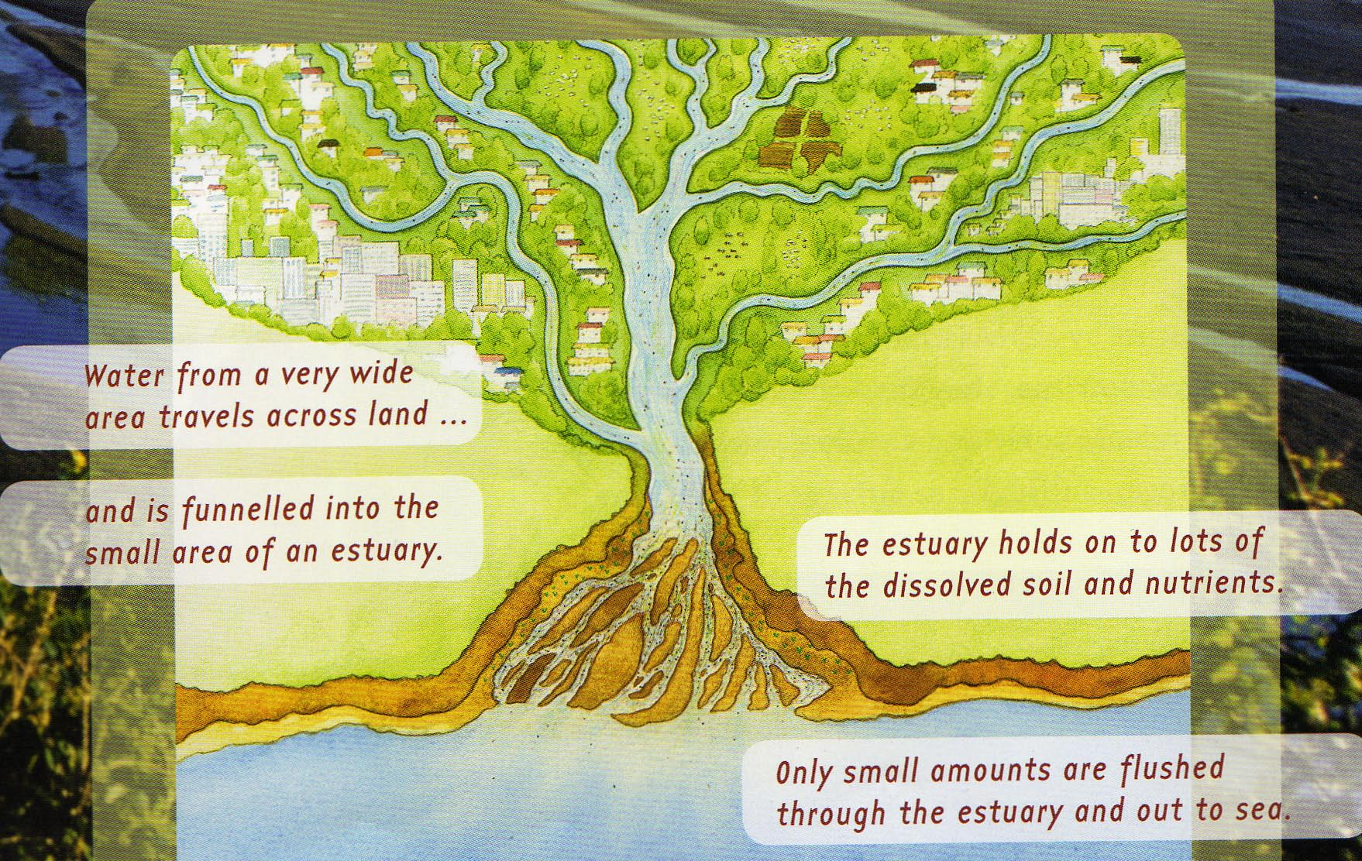

4

……………..

3
sea
1

…………..
2
river

Teacher instructions and listening text: Task 2 (Element 2)

Unit standard 15007, version 5
Understand spoken information and instructions in familiar contexts (ESOL)
Level 2 4 credits

Element 2: Follow multi-step instructions in familiar contexts.

- Read the text out loud.
- Allow a couple of minutes before reading the text a second time.
- Allow time for students to complete and/or check their answers.

Listening text: Task 2 (Element 2)

Read the following to your students

- Find Task 2 and read the questions.
- Now listen to the text and complete these instructions.

Write your name and the date on the dotted lines and underline them

both.
- Draw a picture of a leaf in the blank circle and write the word ‘plants’ in the box below that circle.
- Write the title ‘A food chain’ under the word title and write ‘decomposers’ at the end of the sentence 1.
- Write ‘herbivores’ in box 2 and ‘carnivores’ in box 3.

3. Now check your answers.
Student sheet: Assessment task 2 (Element 2)

Unit standard 15007, version 5
Understand spoken information and instructions in familiar contexts (ESOL)
Level 2 4 credits

Element 2: Follow multi-step spoken instructions in familiar context.

………………………………………………… …………………………….

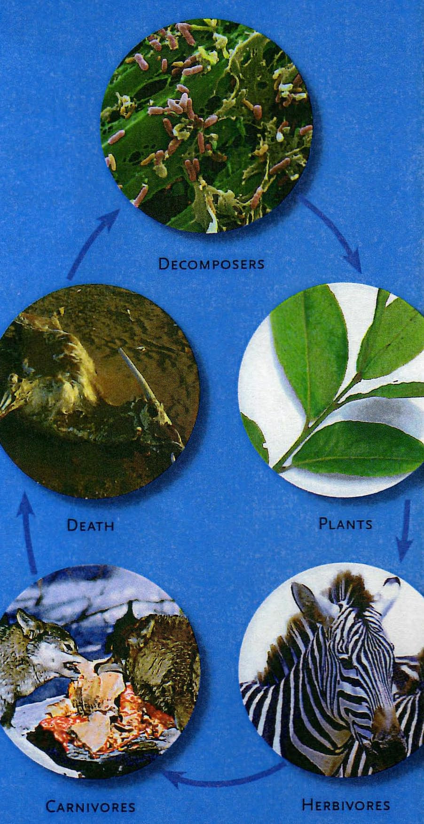

Death

2 ………………………

3 ……………………..
Decomposers

Title:
……………………………….

Sentence 1.
The organisms at the bottom of a food chain are called
…………………………..

Assessment Schedule: Task 1 (Element 1)

Unit standard 15007, version 5
Understand spoken information and instructions in familiar contexts (ESOL)
Level 2 4 credits

Element 1: Understand spoken information in familiar contexts.
Range: Three types of spoken text.
PC | Evidence | Judgement
1.1 | The purpose of the spoken text is identified.  Answer is:  b. to arrange a meeting to do their homework. | The purpose of the spoken text is identified.  Answer is correct.
1.2 | Answers similar to:  2a. To work on their science homework.  2b. He has soccer practice.  2c. Saturday.  2d. At Sam’s house / 24 Smith Road. | Specific information in the spoken text is identified.  3 out of 4 answers are correct.

Assessment Schedule: Task 2 (Element 1)

Unit standard 15007, version 5
Understand spoken information and instructions in familiar contexts (ESOL)
Level 2 4 credits

Element 1: Understand spoken information in familiar contexts.
Range: Three types of spoken text.
PC | Evidence | Judgement
1.1 | The purpose of the spoken text is identified.  Answer is:  d. to tell the class about today’s lesson. | The purpose of the spoken text is identified.  Answer is correct.
1.2 | 2. Answers similar to:  a. Estuaries.  b. Look more closely at water /  Do an experiment.  c. They form layers.  d. Find a partner /  Come and get a materials list. | Specific information in the spoken text is identified.  3 out of 4 answers are correct.

Assessment Schedule: Task 3 (Element 1)

Unit standard 15007, version 5
Understand spoken information and instructions in familiar contexts (ESOL)
Level 2 4 credits

Element 1: Understand spoken information in familiar contexts.
Range: Three types of spoken text.
PC | Evidence | Judgement
1.1 | The purpose of the spoken text is identified.  1. Answer is:  c. to work on a project together. | The purpose of the spoken text is identified.  Answer is correct.
1.2 | 2. Answers similar to:  a. (His dad has given him) lots of extra jobs to do.  b. A diagram / information on physical characteristics.  c. 3 (main groups).  d. Yes. | Specific information in the spoken text is identified.  3 out of 4 answers are correct.

Assessment Schedule: Task 1 (Element 2)

Unit standard 15007, version 5
Understand spoken information and instructions in familiar contexts (ESOL)
Level 2 4 credits
Element 2: Follow multi-step spoken instructions in familiar context.
Range: Two different contexts, each with three multi-step instructions.
PC | Evidence | Judgement
2.1 | 1. Student’s name is written on the dotted line on the left, above the diagram.  2. The date is written on the dotted line on the right, above the diagram.  3. The title “Diagram of an estuary” is written on the dotted line in the middle above the diagram.  4. Box 1 is labeled ‘town area’ and box 4 is labeled ‘farmland’. | Task is completed according to instructions.  3 out of 4 answers are correct.  Both parts of each instruction must be completed correctly.  Note that the answers need not have correct spelling but must be comprehensible.

Assessment Schedule: Task 2 (Element 2)

Unit standard 15007, version 5
Understand spoken information and instructions in familiar contexts (ESOL)
Level 2 4 credits
Element 2: Follow multi-step spoken instructions in familiar context.
Range: Two different contexts, each with three multi-step instructions.
PC | Evidence | Judgement
2.1 | 1. Student’s name and the date are written on the dotted lines and underlined.  2. A picture of a leaf is drawn in the blank circle and the word ‘plants’ written in the box below that circle.  3. The title ‘A Food Chain’ is written  under the word title and the word ‘decomposers’ is written at the end of sentence 1.  4. Box 2 contains the word ‘herbivores’ and box 3 contains the word ‘carnivores’. | Task is completed according to instructions.  3 out of 4 answers are correct.  Both parts of each instruction must be completed correctly.  Note that the answers need not have correct spelling but must be comprehensible.

