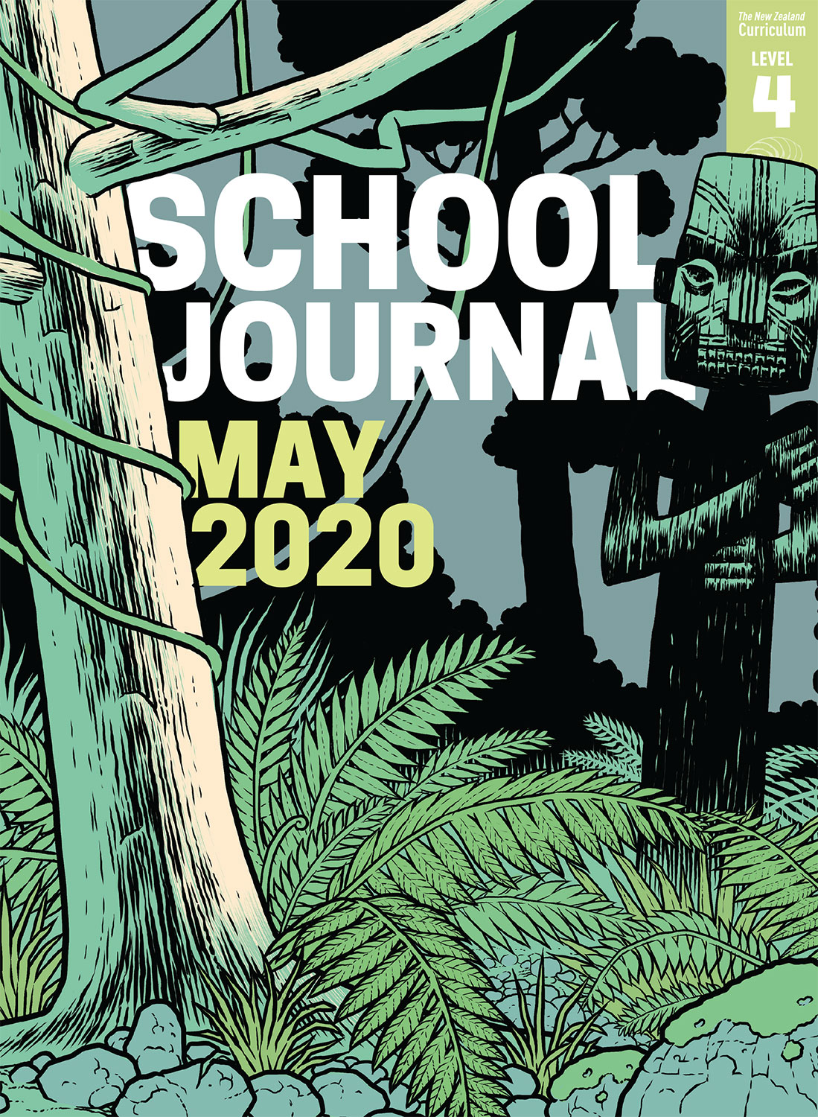

School Journal

Level 4, May 2020

**Year 8**

# Leaves

by Lily Ng

The[Learning Progression Framework](https://curriculumprogresstools.education.govt.nz/lpf-tool/)s describe significant signposts in reading and writing as students develop and apply their literacy knowledge and skills with increasing expertise from school entry to the end of year 10.

## Overview

This poem explores the relationship between the poet and her grandmother who was a refugee from China following the Cultural Revolution.

A PDF of the text is available at [www.schooljournal.tki.org.nz](http://www.schooljournal.tki.org.nz)

## Themes

* Identity
* Sacrifice
* Hardship

## Related texts

“**Family Photographs**” SJ L4 Oct 2015 | “**Thumbprints**” SJ L3 May 2017 | “**Brave Flower**” SJ L4 Nov 2018 |   
“**Chinese New Zealanders**” SJ L4 Nov 2019

## Strengthening reading behaviours (what to notice)

|  |  |
| --- | --- |
| Text structure and features | Requiring students to: |
| * Implied information or ideas * Metaphor and other figurative or connotative language * Some historical or political terms (revolution, regime, and dynasty) that are particularly important for understanding the poem * Flashbacks or time shifts * Moves from the past tense to the present and back again in the second main stanza | * infer as they link their background knowledge to the descriptions in the poem * use word clues and other references in the text to identify the writer’s meaning * link to their background knowledge to interpret the word meanings and understand the wider historical and political context * visualise the two different contexts – China in the time of the Cultural Revolution and New Zealand today * identify the shifts in place and time and understand the difference between direct and indirect memories. |

|  |  |
| --- | --- |
| Vocabulary | |
| Possibly unfamiliar words and phrases | revolution, wide-brimmed, reeds, regime, relentless, sweat-slicked, clasp, dynasty, decades, brown ochre, swaddled, ballast, ravage |
| Words in Cantonese | Mah Mah, hung sik, cheong fun, keipo |
| Metaphor and other figurative or connotative language | One unblinking eye stares from the sky above Canton, twist from the weight of carrying a dynasty, under the gaze of that hot sun, a ballast tied down in a storm |

|  |
| --- |
| Helpful prior knowledge (pre-reading and introducing the text) |
| * Lyall Bay is in Wellington (meaning that the poet and her grandmother now live in New Zealand). * The Chinese Cultural Revolution had terrible effects on the population, including the banishment of many of the intelligentsia (highly educated or academic people) to the countryside to work on farms. |

## Possible reading and writing purposes

* Interpret a grandmother’s story conveyed through her granddaughter’s eyes
* Identify and explore the ways the writer has deliberately used figurative language and structure
* Explore the relationship between the grandmother and her granddaughter using examples from the text
* Synthesise ideas from the poem with those in other texts to understand the reasons why people migrate to new countries

See *Effective Literacy Practice in Years 5–8* for information about teaching comprehension strategies ([Teaching comprehension](http://literacyonline.tki.org.nz/Literacy-Online/Planning-for-my-students-needs/Effective-Literacy-Practice-Years-5-8/Teaching-comprehension)) and for suggestions on using this text with your students ([Approaches to teaching reading](http://literacyonline.tki.org.nz/Literacy-Online/Planning-for-my-students-needs/Effective-Literacy-Practice-Years-5-8/Approaches-to-teaching-reading)).

## Possible curriculum contexts

This text has links to level 4 of the New Zealand Curriculum in:[**ENGLISH**](http://nzcurriculum.tki.org.nz/The-New-Zealand-Curriculum/English)**[SOCIAL SCIENCES](http://nzcurriculum.tki.org.nz/The-New-Zealand-Curriculum/Social-sciences)**

## Understanding progress

The following aspects of progress are taken from the [Learning Progression Framework](https://curriculumprogresstools.education.govt.nz/lpf-tool/)s and relate to the specific learning tasks below. See the LPFs for more about how students develop expertise and make progress in these aspects:

* Reading for literary experience
* Making sense of text: reading critically
* Making sense of text: using knowledge of text structure and features
* Using writing to think and organise for learning.

## Strengthening understanding through reading and writing

The *School Journal* provides rich texts that can be returned to many times. The following suggestions are based on the premise that rereading the text is a fundamental part of developing students’ understanding and reading skills. **Select from and adapt** them, according to your students’ strengths, needs, and experiences.   
Note: Most of these activities lend themselves to students working in pairs or small groups. Be sensitive to the emotional needs of students whose families have come to New Zealand after experiencing trauma or war.

* Have the students brainstorm how surviving a revolution might affect someone in later life. *Could it affect their physical or emotional health? What would they treasure in life? What might they find difficult? How might it affect their relationship with their children and grandchildren? Can you find evidence for any of these ideas in the poem?*
* Review some of the features of poetry to determine what the students already know and notice independently.
* Have the students think, share, and compare their responses to the poem individually, then with a partner, and then in a small group, using the **Poem response** template provided. Make a note of specific aspects to address in a separate lesson.
* Discuss what the poet wants us to feel and how her choice of words makes that clear.
* Explore the impact of the Cultural Revolution in China from the poet’s point of view. Generate some questions for further possible research.
* Ask the students to write a poem about an older relative’s early life.
* Encourage the students to find a connection with the poem, for example, by finishing a sentence that starts “I remember that feeling when …” Have the students explain or describe the feeling.
* Unpack some selected figurative and connotative language. Encourage the students to describe the pictures they create.
* Focus on any aspects of poetry that the students are less familiar with, such as the connotative language.
* Have the students create a Bubble thinking map. Working in pairs, they take a word of interest from the poem and write it in the centre bubble. They then fill in bubbles around the word with synonyms or related words. They could discuss how the poem would be different if one of the other words had been used instead. The pairs could also share their word lists with other students and ask questions about new words they learn.
* For more ideas and strategies to support English language learners, see [ESOL Online](https://esolonline.tki.org.nz/).

“Leaves” Poem response

**Poem Title: Poet:**

|  |  |  |  |  |  |  |  |
| --- | --- | --- | --- | --- | --- | --- | --- |
| Themes: |  | Point of view: | | | |  | Powerful images: |
|  |  |  | | | |  |  |
| Inferences I’ve made: | | |  | Structure and language features I noticed: | | | |
|  | | | | |  | | |
| I think the poet is saying: | | | | | | | |