virtually.together
October: NZATE Conference
Karen Melhuish: English Online
englishonline@learningmedia.co.nz

Unpacking ‘Teaching as inquiry’: how this effective pedagogy model that underpins English Online

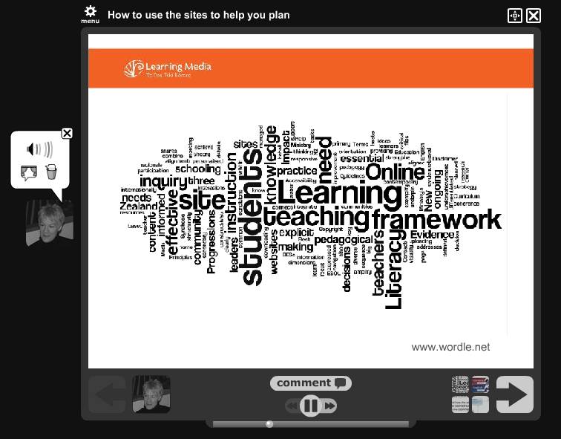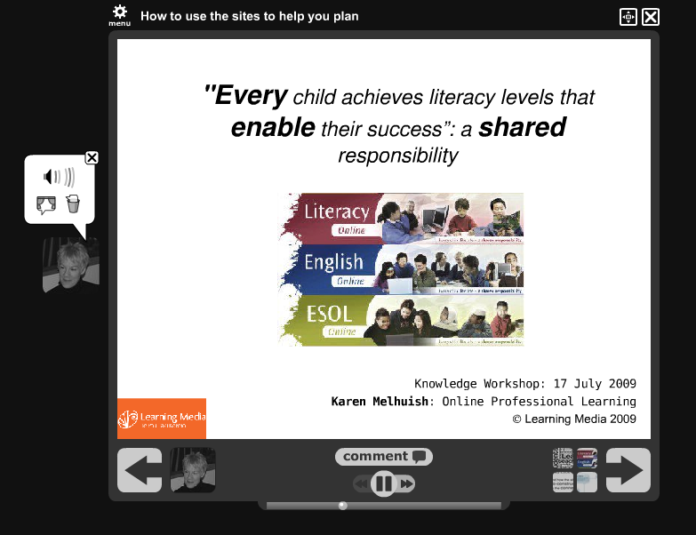

The three sites – English, Literacy and ESOL Online – were launched in February 2009. The sites seek to build on the legacy of their previous versions and support teachers as they actively plan to support their students while giving effect to the new curriculum. But how much time have you had to explore the sites, or consider, ‘What’s in them for me?’

This session at the conference clarified the purpose, vision and scope of the sites, and shared practical ways to use the sites’ resources to support your planning, unpacking key aspects of the NZC from a pragmatic point of view.

Aimed at: any primary / secondary teacher / HoD interested in using the websites and in critiquing their planning in relation to the NZC.

Hurray! You can still access this presentation online: http://voicethread.com/share/564817/

Looking for a planning template?

The workshop recommended that teachers focus on the Teaching as inquiry process (not to be confused with inquiry-based teaching), rather than a set template. Critique your current units against the Teaching as inquiry framework (NZ Curriculum, p. 35): http://nzcurriculum.tki.org.nz/the_new_zealand_curriculum_online/Effective-pedagogy)

What does the inquiry model mean – and what might it look like in practice?

Focusing inquiry: what do my students need to learn?
http://englishonline.tki.org.nz/English-Online/What-do-students-need-to-learn

Teaching inquiry: what do I need to know and do?
http://englishonline.tki.org.nz/English-Online/What-do-you-need-to-know-and-do

Learning inquiry: what is the impact of the teaching?
http://englishonline.tki.org.nz/English-Online/What-is-the-impact-of-your-teaching-and-learning

Other useful resources to unpack the framework

- Teaching as inquiry: Capturing teachers' hearts and minds at Onerahi School: a digital story
http://nzcurriculum.tki.org.nz/Digital-stories/School-snapshots/Onerahi-School

- Teachers as learners: Improving outcomes for Māori and Pasifika students through inquiry
These learning materials are primarily for teachers and school leaders, and they may also be useful for others in education. Their purpose is to illustrate how teachers have used an inquiry approach to teaching to become more culturally responsive and to improve outcomes for their Māori and Pasifika students.
http://nzcurriculum.tki.org.nz/Digital-stories/Case-studies/Inquiry

- Teaching and Learning sequences
These are teaching units that have been developed using the Teaching as Inquiry framework. New ones are in development.
http://bit.ly/CnZvl
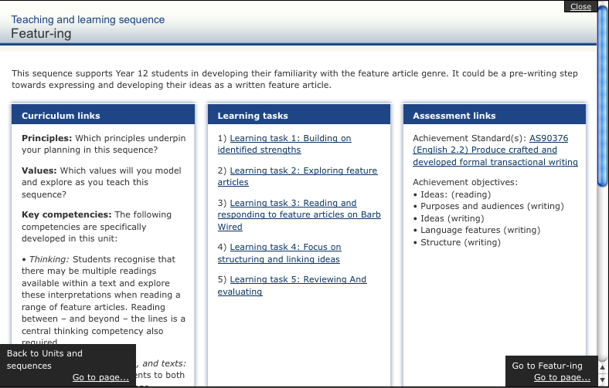

- Information Literacy Model - Teaching as Inquiry Project

From Auckland Girls Grammar School, the information literacy process unpacked in a way that informs the teacher and student of the progress being made.
http://nzcurriculum.tki.org.nz/Media/Files/IJ-files/Information-Literacy-Model-Teaching-as-Inquiry-Project

- Creating a learning environment at Elmgrove School – 2007

” There's lots of ways we learn. Our teachers explain what we need to know and why by using WALTs (We are learning to...), our school vision and GROVER - our inquiry process…”
http://nzcurriculum.tki.org.nz/Digital-stories/School-stories/Elmgrove-School

This article will appear online in the November community newsletter. Have you subscribed yet?
http://englishonline.tki.org.nz/Community-Newsletters

