Siapo Crossword (A)

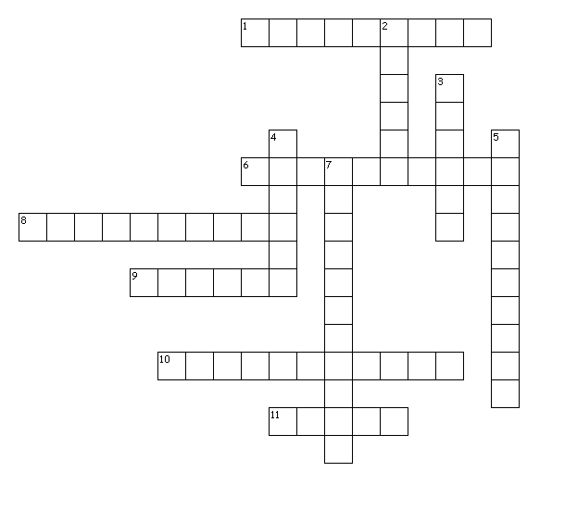

Clues Across
1. to stand for something means to...
6. to fit shapes together without any spaces
8. a tropical flower that is sometimes represented by a symbol of a four-petalled flower
9. an artwork that is created in recent times
10. an artwork that was created a long time ago
11. an artwork found in Samoa which is made from bark

Siapo Crossword (B)

Clues Down
2. a shape or design that is used to represent something
3. to make something turn around a fixed point
4. to plan and make something in a skillful or artistic way
5. when you see an image in a mirror, water or glass
7. a shape that looks exactly the same on each side

Crossword Answers

Across:
1. represent
6. tessellate
8. frangipani
9. modern
10. traditional
11. siapo

Down:
2. symbol
3. rotate
4. design
5. reflection
7. symmetrical

