reflect

rotate

translate

tesselate

symmetrical

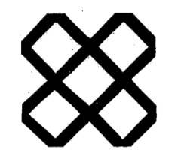
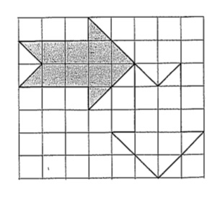

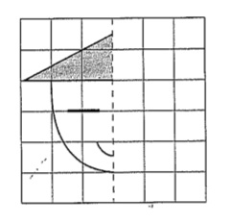

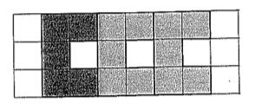

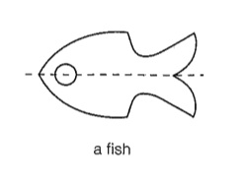

A mirror image.

An object is symmetrical when one half is a mirror image of the other half.

Patterns or shapes that fit together without any gaps.

To turn an object.

To move an item any direction with out rotating it.

