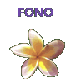
Fatu Feu’u

About the artist
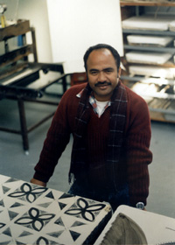
Fatu Feu’u was born in Poutasi Falealili, Samoa, in 1946. He came to New Zealand in 1966 and started to take night classes in art and design. He was employed as a colour consultant and designer at a textile company and began to make abstract paintings in his spare time.

Feu’u is one of the foremost artists of Polynesian descent currently working in New Zealand. He has become renowned for his painting, printmaking and sculpture and has exhibited widely within New Zealand.

Feu’u incorporates a wide range of Samoan and Polynesian symbols and motifs into his artworks such as the four-petalled flower, the frigate bird, carved figures, patterns of sennit lashing around wood and stone. Many of his artworks are based on the grid-like structure of siapo (bark cloth) and include traditional siapo patterns and the formalistic designs used in Samoan tatau (tattoo).

‘The best thing my mother told me was, “You are not going
to get any money because we have not got any money. But
we are very rich. You know why? We are very rich with our
art and our culture.” Now, whenever I paint, I feel I’m doing it
not just for myself, not just for my family, but for my people,
my culture.’
Fatu Feu’u

