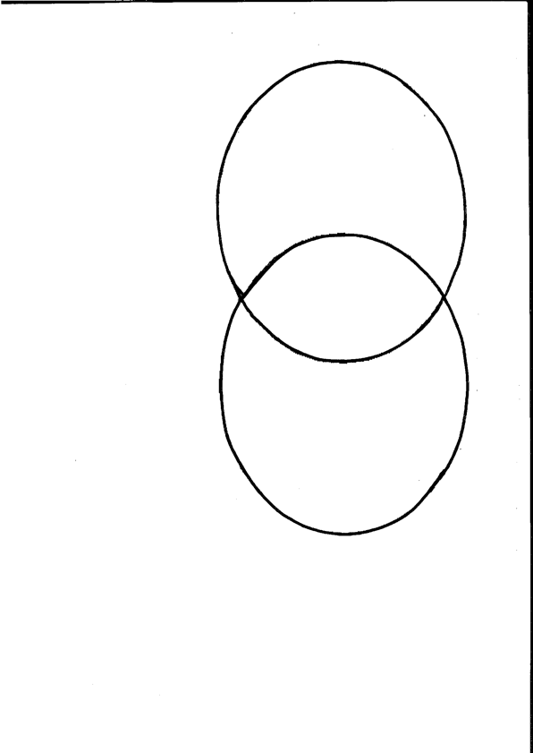
Symbols Used By…

Fatu Feu’u
Michel Tuffery

