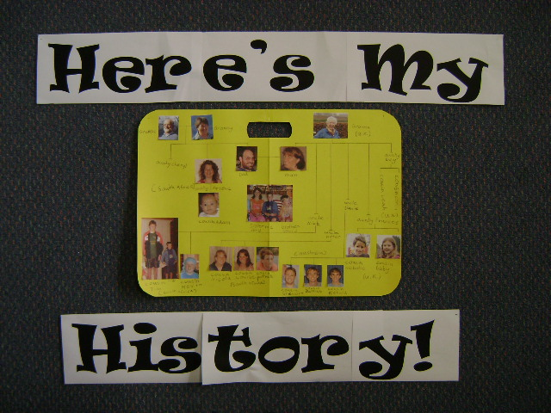
Week __ Homework Project Term __

Here’s My History
We are learning about who we are (our family history).
Do you know about your family history? Here’s a chance to find out more about who you are and where you came from. How will we do that? We’ll ask questions about our Family History, research through photos and talk with our relatives to find out.

Task:

- What do I already know about my family history? Where were my family members born? Write down the names of the members you know:

Relation | First name/s | Last name | Where they were born
Mum
Dad
Brother/s
Sister/s
Aunty/ies
Uncle/s
Granddad/s
Grandmother/s

Any other family members you know? Record them in your homework book.

Grab Bag

- Present this information on a bag shape that shows how the relationships are connected. It could look like a family tree or a collage.
- The presentation style is up to you! Bring the finished work to class ____________. Have fun!!

