CONNECTED, LEVEL 2 2013, I Spy …  Take a Closer Look  by Margaret Cahill  Overview  The article describes how to magnify objects in order to observe them closely and gives examples of how to record these observations.  A Google Slides version of this article is available at www.connected.tki.org.nz. This text also has additional digital content, which is available online at www.connected.tki.org.nz too. |  |  |  |  | 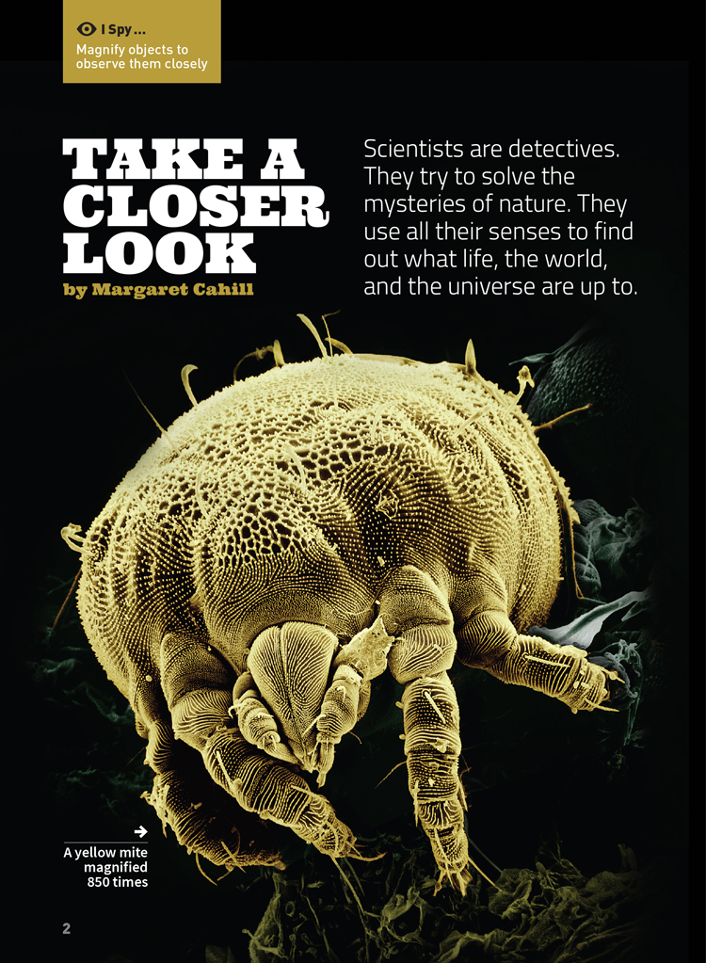
Science capability  Students need to develop a set of capabilities that support them to ask informed questions if they are to participate as “critical, informed, responsible citizens in a society in which science plays a significant role”. The capabilities enable students to meet the achievement objectives in a way that supports the purpose of science in The New Zealand Curriculum and the development of the key competencies. These capabilities include being ready, willing, and able to gather and interpret data. Students need to understand what counts as evidence in science, the importance of observation, and the difference between observation and inference. |  |  |  | Text characteristics  - Many subject-specific words with their meanings explained in the running text or in the glossary  - Breakout text to provide supplementary information  - Clearly structured text with headings that signify the information in each section and help the reader to navigate the text  - Photographs and diagrams that clarify the text and require some interpretation.

Curriculum context
SCIENCE
NATURE OF SCIENCE: Understanding about science  Achievement objective(s)  L2: Students will appreciate that scientists ask questions about our world that lead to investigations and that open-mindedness is important because there may be more than one explanation. |  | NATURE OF SCIENCE: Investigating in science  Achievement objective(s)  L2: Students will extend their experiences and personal explanations of the natural world through exploration, play, asking questions, and discussing simple models. |  |  |  |  | Key Nature of Science ideas  - Science knowledge is based on direct, or indirect, observations of the natural physical world.  - Observation is a key scientific tool.  - Scientists gather data using their senses to make observations.  - Making careful observations often involves measuring something.  - Observations are influenced by what you already know.  - Data gathered from observation helps to answer questions about our world.  - Some features are visible and can be easily observed.  - Magnification makes a section of an object bigger to show features that were not visible before.

ENGLISH
READING  Ideas  L2: Students will show some understanding of ideas within, across, and beyond texts. |  | INDICATORS  - Uses their personal experience and world and literacy knowledge to make meaning from texts.  - Makes meaning of increasingly complex texts by identifying main ideas.  - Makes and supports inferences from texts with some independence. |  |  |  | THE LITERACY LEARNING PROGRESSIONS  The literacy knowledge and skills that students need to draw on by the end of year 4 are described in The Literacy Learning Progressions.

Scientific investigation
A science investigation where you change or try something and observe what happens is called an experiment. Not all scientific investigations are experiments; there are many ways of investigating in science. The New Zealand Curriculum science achievement aims indicate that students should experience a range of approaches to scientific investigation including classifying and identifying, pattern seeking, exploring, investigating models, fair testing, making things, and developing systems. Many scientific investigations involve systematic observation over time of an object, an event, a living thing, or a place.  Some important things to remember when you do a scientific investigation are: to be systematic and fair; to make sure that only one thing is changed at a time if you are doing an experiment or fair test so you are sure which changes result in which outcome; to observe and record what happens very carefully; and to be open minded so you notice things you are not expecting. |  |  |  | Sound data is obtained when you are able to get similar outcomes each time you do the same thing, or when data has been collected in the same way and in a systematic manner. No investigation or experiment results in a “wrong” outcome. You may have done something differently from others or the conditions may be slightly different so you don’t get the same result as others do, but it is not “wrong”.  Thinking about and developing explanations about why things happen the way they do, based on evidence, is an important aspect of science. Another important aspect is critically evaluating methods and ideas. Part of a scientist’s work is critiquing and evaluating the methods and ideas of other scientists. They expect their work to be subject to critique. If they are going to be able to make informed decisions about scientific issues as responsible citizens, students first need to experience a range of approaches to scientific investigation and to practise critique and evaluation of scientific methods and ideas – both their own and those of others – just like scientists do!

Meeting the literacy challenges

The following strategies will support students to understand, respond to, and think critically about the information and ideas in the text. After reading the text, support students to explore the key science ideas outlined in the following pages.  TEXT CHARACTERISTICS  - Many subject-specific words with their meanings explained in the running text or in a glossary  - Breakout text provides supplementary information  - Clearly structured text with headings that signify the information in each section and help the reader to navigate the text  - Photographs and diagrams that clarify the text and require some interpretation. |  | TEACHER SUPPORT  Want to know more about instructional strategies? Go to:  http://literacyonline.tki.org.nz/Literacy-Online/Teacher-needs/Pedagogy/Reading#Years1-4  http://literacyonline.tki.org.nz/Literacy-Online/Teacher-needs/Pedagogy/Reading#Years5-8  http://literacyonline.tki.org.nz/Literacy-Online/Student-needs/National-Standards-Reading-and-Writing  http://www.literacyprogressions.tki.org.nz/  “Working with Comprehension Strategies” (Chapter 5) from Teaching Reading Comprehension (Davis, 2007) gives comprehensive guidance for explicit strategy instruction in years 4–8.  Teaching Reading Comprehension Strategies: A Practical Classroom Guide (Cameron, 2009) provides information, resources, and tools for comprehension strategy instruction.

INSTRUCTIONAL STRATEGIES
This text also has additional digital content that is available online at www.connected.tki.org.nz  FINDING THE MAIN IDEAS  “Take a Closer Look” is both an explanatory and a procedural text. It describes some of the tools that scientists use to make observations. It also explains the processes for scientific observation, organising this information under headings that indicate the main ideas.  MODEL how to make a connection to the title, using prior knowledge about detectives and observing carefully.  - This makes me think about detectives and the way they look closely at the evidence.  PROMPT the students to summarise the first paragraph to unpack the author’s purpose.  - What do we know about what scientists do? How is this similar to what detectives do?  Conduct a shared reading of page 3. Clarify that this is a procedural text. Get the students to SKIM the rest of the text and use the headings to identify the four steps scientists undertake in order to understand how nature works: observe, gather data, record data, and interpret data. Then ask them to SCAN the text on page 4 to find the instructions about using scientific processes to observe and gather data about leaves.  Remind the students that skimming and scanning are helpful strategies for finding the main ideas in an article.  MODEL note taking as you list the steps outlined on pages 4 and 5. Ask the students to mentally note any more steps in the procedure as they continue reading to the end.  Encourage the students to share their ideas about the text and ask them, in pairs, to complete their list of processes and then to compare their lists with the rest of the group. |  | DEALING WITH UNFAMILIAR VOCABULARY  EXPLAIN to the students that many words in this text may be unfamiliar to them. Point out that some of these words are explained in the glossary and some are explained in the text. PROMPT them to read on for a sentence when they are unsure.  DISCUSS the concept of “scientific language” that is explained on page 5.  - Can you think of other examples you know of where people use specialised language? Why do you think that is?  Students can identify and record vocabulary that is new to them in these articles and compile their own glossaries, adding meanings in their own words.  Use the photographs on pages 6 and 7 to develop the students’ understanding of “magnification”.  DISCUSS the differences between telescopes and microscopes using the different prefixes and the shared suffix. Explain that “micro-” means “small” or “millionth” and “tele-” means “distance”, “far”, or “from afar”.  - What do you suppose the suffix “-scope” means? (“to look”) When you put those prefixes together with that shared suffix, what do you suppose those words mean? Can you think of other words that begin with “micro-” or “tele-”. What do you think they mean?

Teacher support
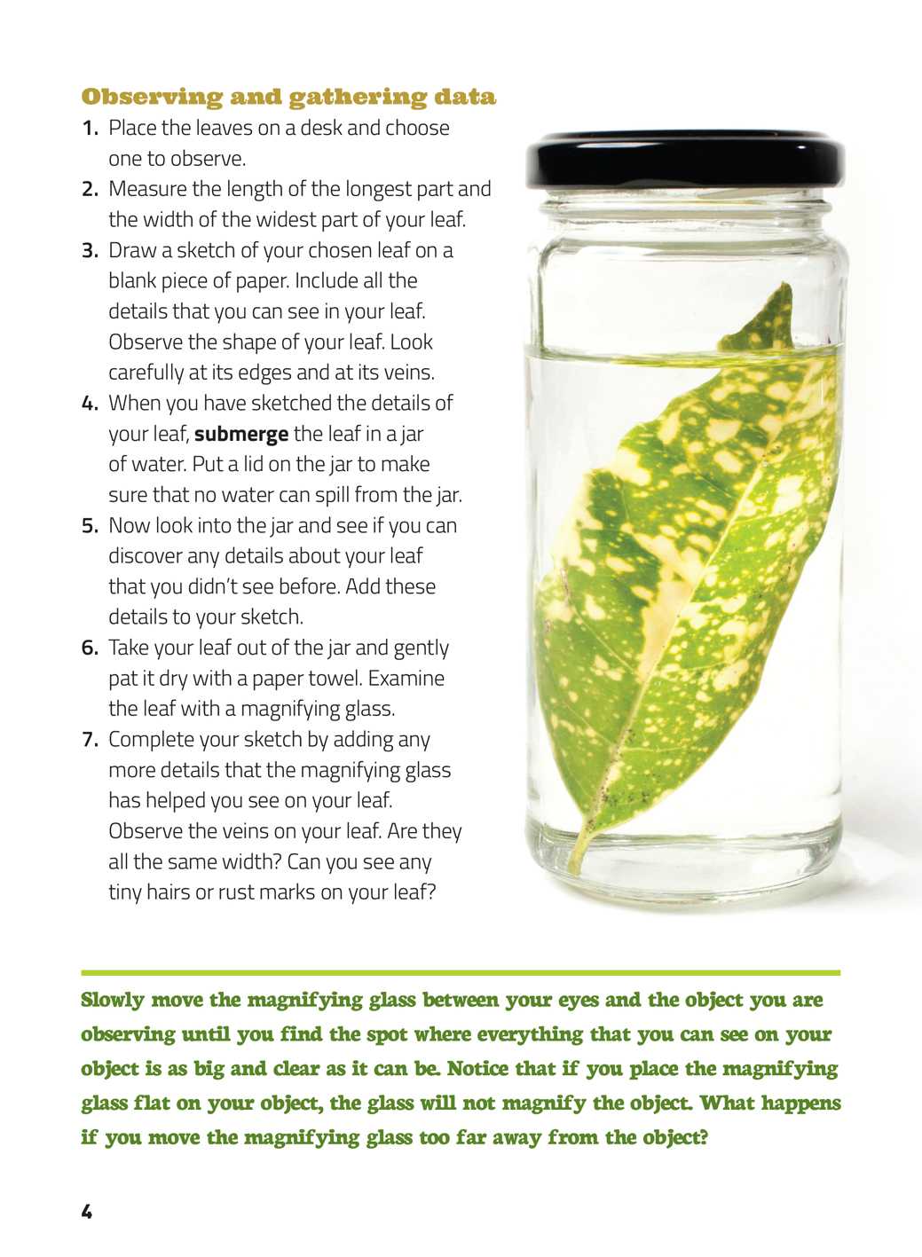 | Some features are visible and can be easily observed.  Magnification makes a section of the object appear bigger to show features that were not visible before.  Observation is a key scientific tool.  Making careful observations often involves measuring something.
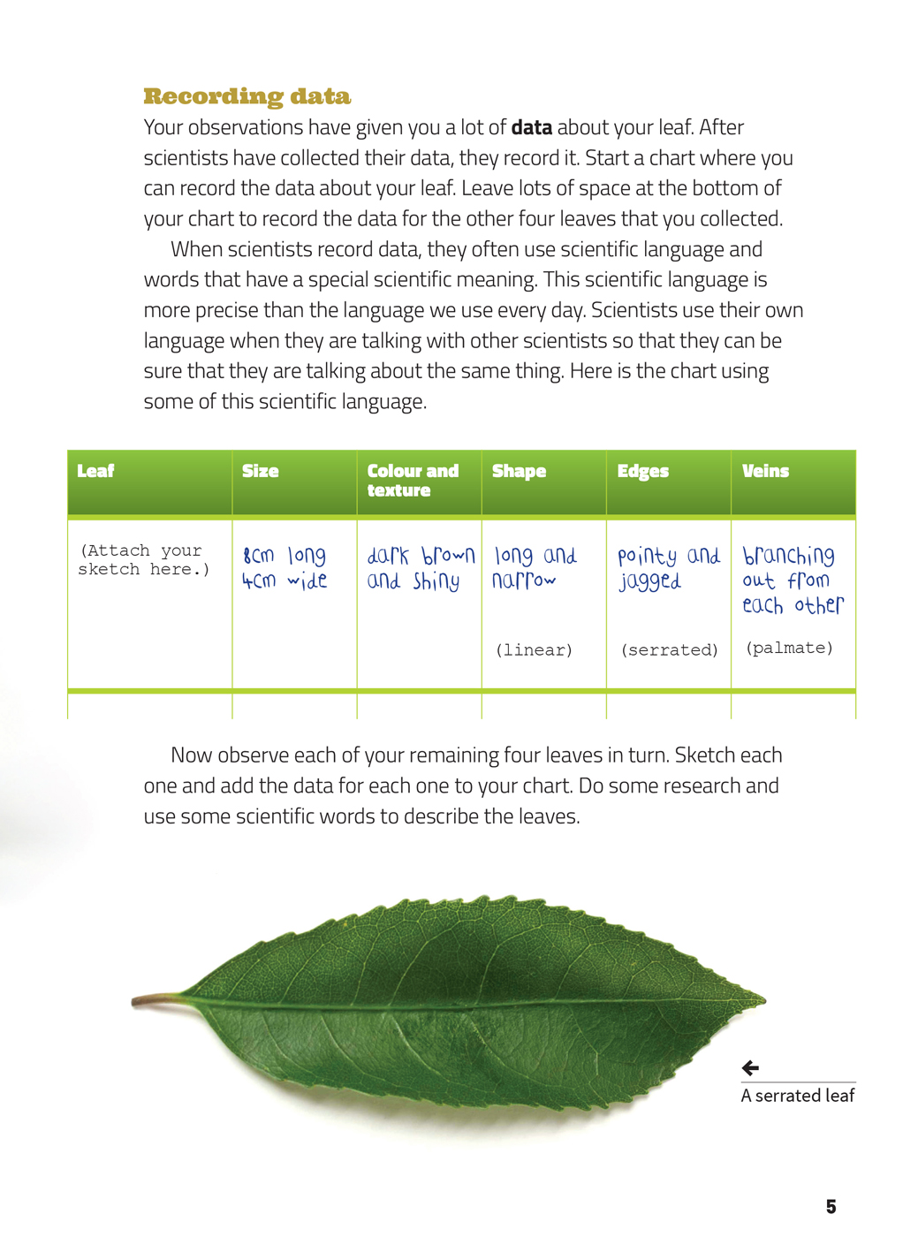 | Science knowledge is based on direct observation of the natural physical world.  Data gathered from observation helps to answer questions about our world.  Observations are influenced by what you already know.  Students develop scientific vocabulary by using scientific language.

Exploring the science
Some activities focus directly on the science capability of “gathering and interpreting data” and the Nature of Science strand. Other activities extend student content knowledge. You are encouraged to adapt these activities to make the focus on Nature of Science explicit and to support students to develop the capability to collect and interpret data.
LEARNING FOCUS |  | KEY SCIENCE IDEAS
Students make observations, gather data, and interpret and discuss outcomes based on their observations. |  | Key Nature of Science ideas  - Science knowledge is based on direct, or indirect, observations of the natural physical world.  - Observation is a key scientific tool.  - Scientists gather data using their senses to make observations.  - Making careful observations often involves measuring something.  - Observations are influenced by what you already know.  - Data gathered from observation helps to answer questions about our world.  - Some features are visible and can be easily observed.  - Magnification makes a section of an object bigger to show features that were not visible before.
LEARNING ACTIVITIES

Activity 1: Looking at leaves
Ask the students to carry out observations of leaves (as detailed in the text) using water in a jar, as well as a magnifying glass. Tell them to record their observations using the table in the article.
Leaf | Size | Colour and texture | Shape | Edges | Veins
(Attach your sketch here.) | 6 cm long  4 cm wide | dark brown and shiny | long and narrow  (linear) | pointy and jagged  (serrated) | branching out from each other  (palmate)
Your students could record their observations using an adapted version of the graphic organiser that accompanies these materials. The table provided is adaptable in Word in case your focus changes.
Support the students to interpret the data they collect.
- The author tells us that the “shape and texture of leaves can tell us how plants have adapted to their environment.” Look at each of the leaves you have collected. How do you think their shape and texture might help them to survive?

Extension
Students could gather more data about leaves by exploring the Sci Media collection of fern images.
Alternatively, they could repeat this activity, looking at feathers and using the Zoom Gallery website.

Activity 2: What am I?
Ask the students to create a “What am I?” display using magnified photos of everyday classroom things. They could take their own photos using a USB microscope or use the Google Slides digital content provided with this Connected article. They could develop three clues to help others identify their magnified object.

Activity 3: What is this for?
The students could create caption statements for their “What am I?” display relating structure to function, for example, in relation to a whiteboard eraser: I can see lots of little bits and loops sticking out. These might help trap the bits of whiteboard marker and remove them from the board.
Alternatively, the students could look at two images of the same object, one showing the whole thing and one a magnification. Ask them to note two observations and inferences they can make from seeing the whole object and two from looking more closely: I can see …, I think that …
You could model this first, using an image of a duck.
Complete picture of a duck: I can see it has webbed feet. I think that webbing might help it swim faster.
Magnification of duck feather: I can see there are jagged bits. I think that they might help the feathers stick together to keep the duck dry.

Activity 4: Looking into looking glasses
Have the students work in groups to research the history and development of the magnifying glass and of different types of microscopes and telescopes. As they do so, encourage them to explore different types of lenses and curved mirrors (for example, shiny spoons).
When the students have completed their research, ask them to report their findings, selecting from the following options:
- create a timeline showing how and when lenses were developed and how they have changed
- write an explanation about how magnifiers have changed
- write a procedure giving instructions for someone else to make a simple magnifier.
After the groups have shared their findings, discuss the links between technological improvements and scientific research.

Extension
Some students may like to read and report on the Science Learning Hub article, “Using a Microscope to Look Closer: Which Microscope Is Best?”.

Activity 5: Look through water
Scientists in ancient civilisations observed that water could magnify an object. Try this experiment to discover how water magnifies.
You will need:
- a page of text from a glossy magazine
- a small container of water
- a pencil.
Create a drop of water by dipping your pencil into the water and then letting a drop drip from the tip of the pencil. Hold the pencil over the magazine page and let the water drop on to it. What do you notice? Experiment to find out whether it’s the water alone or some additional aspect of it that magnifies.

Make a glass magnifier
Fill a glass jar with water. Hold a ruler behind the jar, with the centre of the ruler right behind the jar and the ends protruding on both sides. Stand in front of the jar and read the ruler. What do you notice?
Hold a page of print behind the jar and read the print. Move the jar a little. Observe what happens when you move the jar away from the print. What happens when you move it closer to the print?

Activity 6: Take a look at what’s in the soil

Equipment
For each group you will need:
- a 1 m length of string
- 4 stakes of wood about 15 cm long
- 3 plastic containers the size of a 1 l (litre) ice cream container
- a small gardening trowel
- a felt-tip pen
- paper
- a pencil.
Take these items with you into the playground.
Find three different soil environments in the playground. Places to investigate include:
- under bark chips
- in the sandpit
- under grass
- in the compost bin.

Observing and gathering data
After choosing your soil sites, use the felt-tip pen to label each container with the name of one site. Record your observations of each site on a chart. Consider:
- Is it a sunny or a shaded area?
- Is it damp or dry?
- Is the soil open to the weather or covered with rocks, stones, mulch, or rubbish?
- Do people walk or drive over this area?
- Do people garden in this area?
- What’s growing in this area?
You are now ready to collect a soil sample. Use the wooden stakes to make a square with your string over the first site. Dig into the site with the trowel. Remove a handful of soil and put it into a plastic container. Now move to your other sites and collect two more soil samples.

Observing, gathering, and recording data
Back in the classroom, examine each sample one at a time. Use your senses to describe the samples. Record colours, textures, and smells. Note everything you can see in each sample.
When you have examined your samples with your senses, continue the examination with a magnifying glass. Record your observations with a different coloured pen.
Next, examine your soil samples under a microscope. It will be easier for you to do this as a group with a digital microscope, as your group can examine and discuss the images at the same time. Also you will be able to move the microscope across your soil sample more easily.
However, this is an opportunity for you to use an optical microscope, as well. Compare the two types of microscope. Which one is easier to use? Which one has the clearer images? Which one has the higher magnification? [Students will need to be supported in the correct use of these microscopes.]
Record your observations from the microscope images, using another different coloured pen.
As a group, design a chart to record your observations of the three soil samples. The chart should indicate which tools were used to make the observations – your eyes, a magnifying glass, or a microscope.

Interpreting data
Your chart is complete when all your data is recorded. Then you are ready for the next step of your scientific study: interpreting the data.
Compare your observations of the three soil samples.
- What are the differences between the soil samples? What might cause these differences? Record your ideas. How could you test them?
Google Slides version of “Take a Closer Look” and additional digital content www.connected.tki.org.nz

RESOURCE LINKS

Making Better Sense of the Living World – “Investigation 3, Sorting Leaves” (page 33)
Science Online www.scienceonline.tki.org.nz
Assessment Resource Banks http://arb.nzcer.org.nz/
Science Learning Hub “Using a Microscope to Look Closer: Which Microscope Is Best?” http://www.sciencelearn.org.nz/Contexts/Exploring-with-Microscopes
Sci Media http://www.sciencelearn.org.nz/Contexts/Ferns/Sci-Media
Zoom Gallery: Feathers Up-close http://askabiologist.asu.edu/images/feather-gallery

Leaf | Size | Colour and texture | Shape | Edges | Veins
(Attach your sketch here.)

(Attach your sketch here.)

(Attach your sketch here.)

(Attach your sketch here.)

(Attach your sketch here.)

