CONNECTED, LEVEL 4 2013, Are You Sure?  After the Spill  by Maria Gill  Overview  This article is about the oil spill caused by the grounding of the Rena on Astrolabe Reef. Students read about the research undertaken by scientists and local iwi to overcome the effects of the oil spill on local marine life and the environment.  A Google Slides version of this article is available at www.connected.tki.org.nz. This text also has additional digital content, which is available online at www.connected.tki.org.nz too. |  |  |  |  | 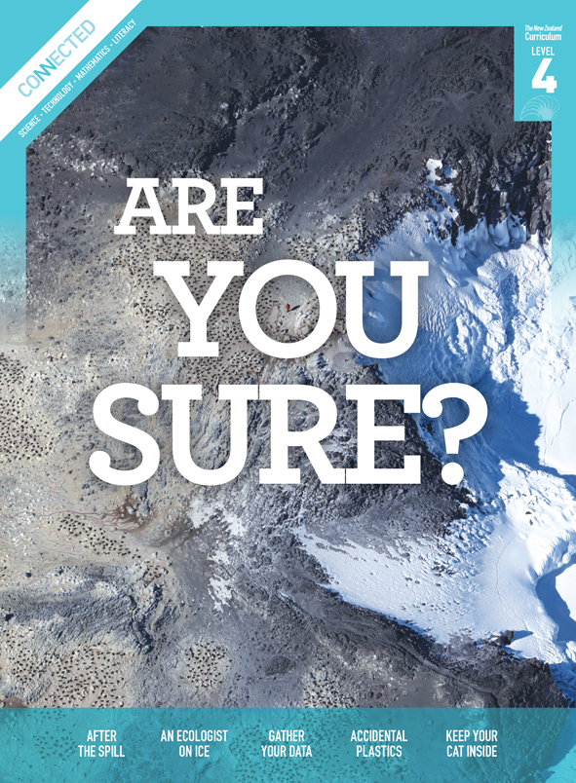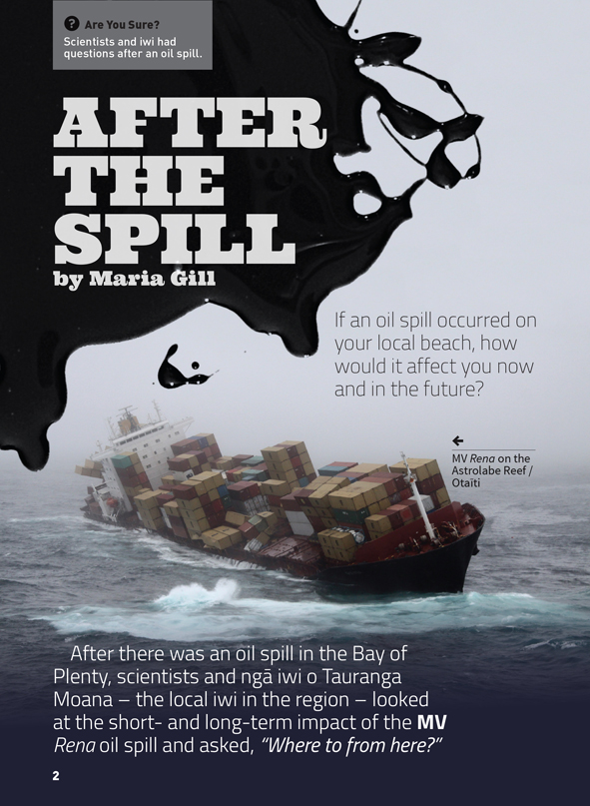
Science capability  Students need to develop a set of capabilities that support them to ask informed questions if they are to participate as “critical, informed, responsible citizens in a society in which science plays a significant role”. The capabilities enable students to meet the achievement objectives in a way that supports the purpose of science in The New Zealand Curriculum and the development of the key competencies. These capabilities include being ready, willing, and able to gather and interpret data. Students need to understand what counts as evidence in science, the importance of observation, and the difference between observation and inference. |  |  |  | Text characteristics  - Abstract ideas and concepts, and lengthy sections of explanatory text  - Illustrations, photographs, text boxes, a diagram, a map, and a newspaper item containing main ideas that relate to the text’s content  - Scientific vocabulary and terminology.

Curriculum context
SCIENCE
NATURE OF SCIENCE: Understanding about science  Achievement objective(s)  L4: Students will identify ways in which scientists work together and provide evidence to support their ideas.  NATURE OF SCIENCE: Participating and contributing  Achievement objective(s)  L4: Students will use their growing science knowledge when considering issues of concern to them.  L4: Students will explore various aspects of an issue and make decisions about possible actions. |  | LIVING WORLD: Ecology  Achievement objective(s)  L4: Students will explain how living things are suited to their particular habitat and how they respond to environmental changes, both natural and human-induced. |  |  |  |  | Key Nature of Science ideas  - Science knowledge is based on direct, or indirect, observations of the natural physical world.  - Scientists gather data using their senses to make observations.  - Making careful observations often involves measuring something.  - Observations are influenced by what you already know.  Key science ideas  - Plants and animals have particular habitats.  - Plants and animals respond to changes in their environment in different ways.  - Environmental changes can have positive and negative effects on living things.

ENGLISH
READING  Ideas  L4: Students will show an increasing understanding of ideas within, across, and beyond texts. |  | INDICATORS  - Makes meaning of increasingly complex texts by identifying and understanding main and subsidiary ideas and the links between them.  - Makes connections by thinking about underlying ideas within and between texts from a range of contexts.  - Recognises that there may be more than one reading available within a text.  - Makes and supports inferences from texts with increasing independence. |  |  |  | THE LITERACY LEARNING PROGRESSIONS  The literacy knowledge and skills that students need to draw on by the end of year 8 are described in The Literacy Learning Progressions.

Scientific investigation
A science investigation where you change or try something and observe what happens is called an experiment. Not all scientific investigations are experiments; there are many ways of investigating in science. The New Zealand Curriculum science achievement aims indicate that students should experience a range of approaches to scientific investigation including classifying and identifying, pattern seeking, exploring, investigating models, fair testing, making things, and developing systems. Many scientific investigations involve systematic observation over time of an object, an event, a living thing, or a place.  Some important things to remember when you do a scientific investigation are: to be systematic and fair; to make sure that only one thing is changed at a time if you are doing an experiment or fair test so you are sure which changes result in which outcome; to observe and record what happens very carefully; and to be open minded so you notice things you are not expecting. |  |  |  | Sound data is obtained when you are able to get similar outcomes each time you do the same thing, or when data has been collected in the same way and in a systematic manner. No investigation or experiment results in a “wrong” outcome. You may have done something differently from others or the conditions may be slightly different so you don’t get the same result as others do, but it is not “wrong”.  Thinking about and developing explanations about why things happen the way they do, based on evidence, is an important aspect of science. Another important aspect is critically evaluating methods and ideas. Part of a scientist’s work is critiquing and evaluating the methods and ideas of other scientists. They expect their work to be subject to critique. If they are going to be able to make informed decisions about scientific issues as responsible citizens, students first need to experience a range of approaches to scientific investigation and to practise critique and evaluation of scientific methods and ideas – both their own and those of others – just like scientists do!

Meeting the literacy challenges

The following strategies will support students to understand, respond to, and think critically about the information and ideas in the text. After reading the text, support students to explore the key science and technology ideas outlined in the following pages.  TEXT CHARACTERISTICS  - Abstract ideas and concepts, and lengthy sections of explanatory text  - Illustrations, photographs, text boxes, diagrams, maps, charts, and graphs, containing main ideas that relate to the text’s content  - Scientific vocabulary and terminology. |  | TEACHER SUPPORT  Want to know more about instructional strategies? Go to:  http://literacyonline.tki.org.nz/Literacy-Online/Teacher-needs/Pedagogy/Reading#Years5-8  http://literacyonline.tki.org.nz/Literacy-Online/Student-needs/National-Standards-Reading-and-Writing  http://www.literacyprogressions.tki.org.nz/  “Working with Comprehension Strategies” (Chapter 5) from Teaching Reading Comprehension (Davis, 2007) gives comprehensive guidance for explicit strategy instruction in years 4–8.  Teaching Reading Comprehension Strategies: A Practical Classroom Guide (Cameron, 2009) provides information, resources, and tools for comprehension strategy instruction.

INSTRUCTIONAL STRATEGIES
This text also has additional digital content, which is available online at www.connected.tki.org.nz.  FINDING THE MAIN IDEAS  Have the students scan the headings and photographs, PROMPTING them to make connections to their prior knowledge and to predict what the article may be about.  - What do you know about this oil spill?  - What role do you think scientists might have played, “after the oil spill”?  - What role do you think iwi might have played, “after the oil spill”?  ASK QUESTIONS to support the students to make connections to identify the author’s purpose.  - What is the author’s purpose for writing this article? What is your evidence for this?  MODEL how to use the clues on the first page of the article to construct a graphic organiser on which to RECORD the information from the text.  EXPLAIN that recording these details will support the students’ comprehension as they work through the article.  ASK QUESTIONS to support students to identify the main ideas.  - What is the significance of scientists and local iwi working together? Is this important? Why?  - What important information did scientists find from their research that could be useful in a similar incident?  - What important information did iwi provide to the research that could be useful in a similar incident?  - What else might be useful information to know in the future?  PROMPT the students to respond to the text by writing a letter or article explaining the impact of the Rena oil spill on the environment. |  | USING DESIGN FEATURES FOR DEEPER UNDERSTANDING  ASK QUESTIONS to draw out the idea that articles often contain additional information that supports the main ideas.  - How does the newspaper article on page 3 add interest to the article?  - How do the photographs add interest to the text?  - What do you learn from the map on page 4 that you wouldn’t understand just from reading the article?  - What does the diagram on page 7 add? [Understanding the actual process of how these animals (mussels) feed emphasises how vulnerable they are.]  DEALING WITH UNFAMILIAR VOCABULARY  IDENTIFY the scientific vocabulary that may challenge some students, for example “toxins”, “filter-feeding”, “ethanol”, and “intertidal”.  PROMPT the students to locate meanings for unknown words by using the text or contextual clues.  Students can IDENTIFY and RECORD new vocabulary and compile glossaries, adding meanings in their own words. Ensure that you give them multiple opportunities to practise using their new vocabulary as they carry out authentic activities as scientists.  Note that “Mātauranga Māori” is not simply “Māori knowledge”. It is the knowledge base from te ao Māori that has been formulated, researched, analysed, and debated over centuries.
  Rena oil spill
  Short-term effects | Long-term effects
  Where to from here?

Teacher support
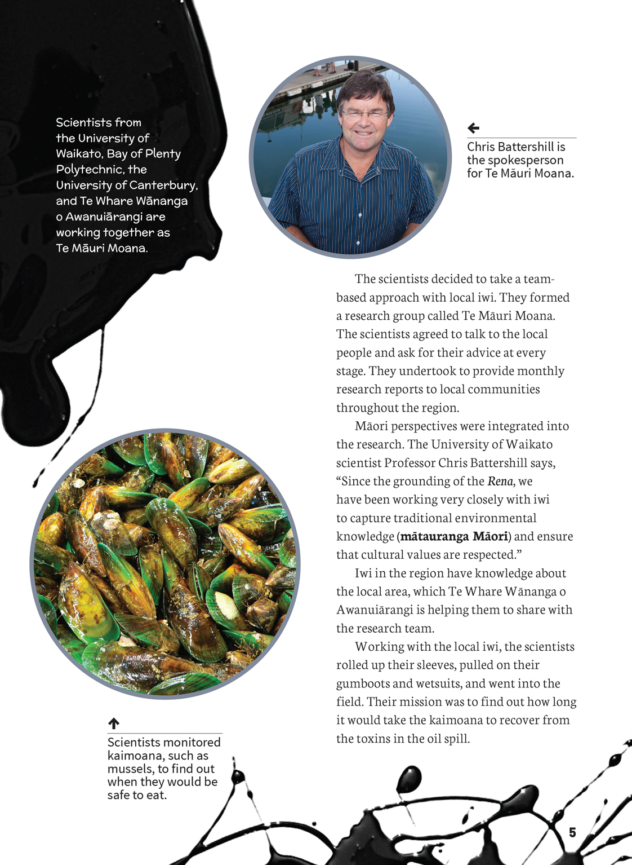 | Scientists and iwi gather data by making careful observations.  Scientists and iwi worked together to provide evidence to support their ideas and to check the validity of their ideas.  Observations are influenced by what you already know.
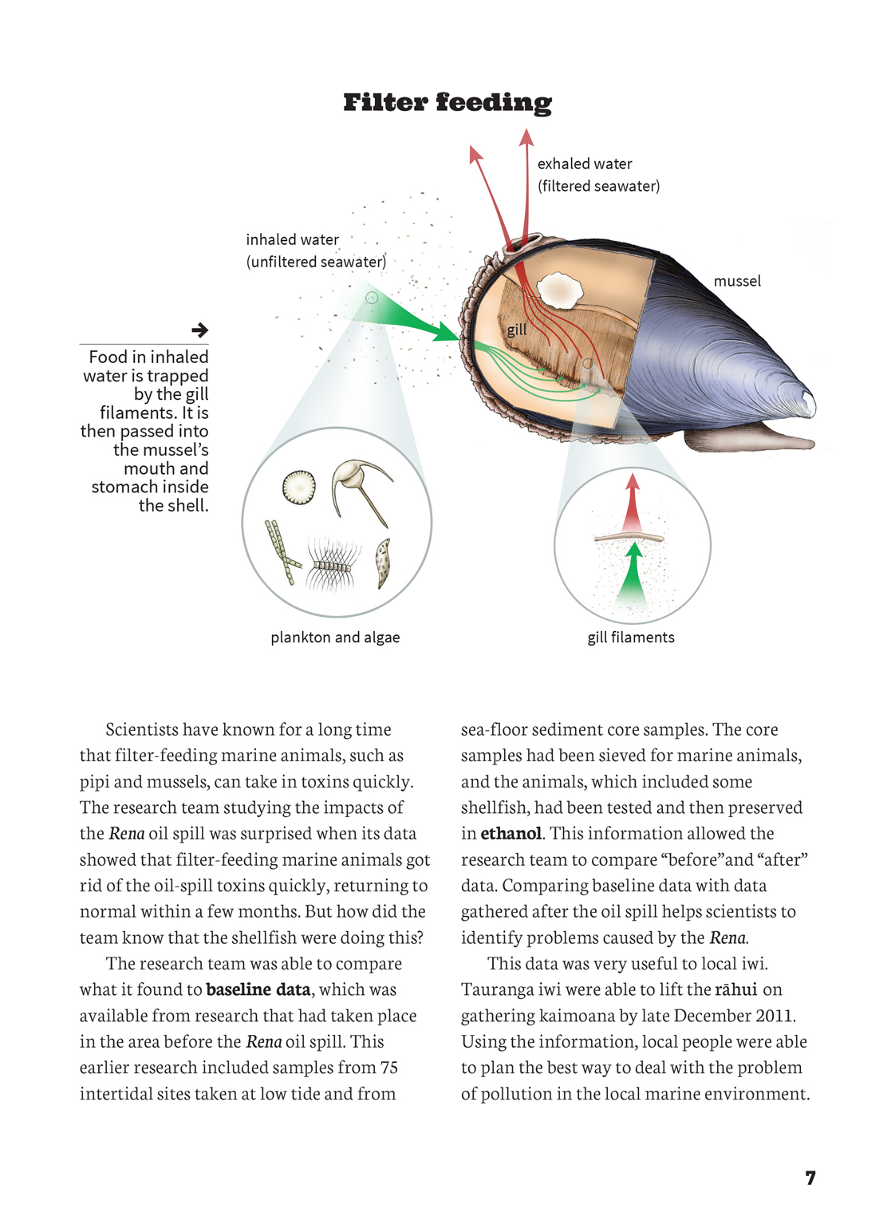 | Living things respond to changes in their environment in different ways.  Scientists and iwi explore various aspects of an issue and make decisions about possible actions.  Scientific knowledge is based on direct, or indirect, observations and interpretations of patterns and trends in the data.

Exploring the science
Some activities focus directly on the science capability of “gathering and interpreting data” and the Nature of Science strand. Other activities extend student content knowledge. You are encouraged to adapt these activities to make the focus on Nature of Science explicit and to support students to develop the capability to collect and interpret data.
LEARNING FOCUS |  | KEY SCIENCE IDEAS
Students make observations, gather data, and interpret and discuss outcomes based on their observations. |  | Key Nature of Science ideas  - Science knowledge is based on direct, or indirect, observations of the natural physical world.  - Scientists gather data using their senses to make observations.  - Making careful observations often involves measuring something.  - Observations are influenced by what you already know.  Key science ideas  - Plants and animals have particular habitats.  - Plants and animals respond to changes in their environment in different ways.  - Environmental changes can have positive and negative effects on living things.
LEARNING ACTIVITIES

Activity 1: Where land meets sea
The Science Learning Hub has an extensive array of resources on the Rena disaster, including video footage and media items. You can also find information on the response to the oil spill on Maritime New Zealand’s website. The School Journal article “What a Disaster!” provides an opportunity for students to consider the grounding from the perspective of a young girl and is accompanied by its own set of teacher support material. All these could be used to amplify a graphic organiser developed during the reading process.

Activity 2: Interpreting the data
There are numerous opportunities for students to collect and interpret data related to the Rena disaster. You could have them:
- look at weather patterns and tide tables and interpret the data to make statements about why the northern end of Mōtītī Island is still affected when there is stormy weather
- locate the Rena wreck on a maritime chart. Use the information on the chart, media, and research reports to find out how much oil was on the ship, how much has been removed, and how much may be remaining. What data would you need to estimate how long it could take for the remaining oil to leak out?

Activity 3: Using drama to deepen students’ conceptual understandings
Telling Our Stories: Classroom Drama in Years 7–10 is a Ministry of Education resource that explains and demonstrates how classroom drama can be a powerful means for inspiring creative and innovative thinking about the big issues in life. Consideration of the Rena disaster could provoke students to engage in questions about the environment and our relationship with it. The Science Learning Hub suggests a teaching and learning activity that involves students considering responses to an environmental disaster and then participating in a role-play in which they draw up a response plan for a similar occurrence.
An alternative to a role-play would be for students to follow research into the Rena disaster’s impact with hot seating. Hot seating is a drama convention in which group members question a person who is playing a role, bringing out additional information, ideas, and attitudes about the role. It can be a valuable technique for bringing out different perspectives. In this instance, these might include those of:
- a member of a local iwi or hapū
- a scientist who belongs to Te Māuri Moana
- a journalist covering the grounding and its impact
- a local who was involved in the clean-up
- a sailor from the Rena
- a member of the local council.
The hot seating might take place in the context of a press conference, from which the students could write up newspaper articles, continuing in the role as journalists. Questions that could be asked are:
- What evidence did they have that the oil spill was damaging?
- What did they see or smell?
- How widespread was it? How do they know?
- How did it affect them personally?

Activity 4: Food web
A food web or food chain is a model of the feeding relationships in communities. (See also the food web diagram, on page 12, in the article “An Ecologist on Ice”.) They can be used to communicate the concept that living things in a community interact with each other and that disruption at one point in the chain will disrupt the rest of the chain. If the students are unfamiliar with the concept of a food chain, you could use the Science Online page about their construction as an introduction. You may wish to explain that, because creatures at the bottom of the food chain tend to be predated by more than one creature, a food web can provide a more accurate picture of reality.
The students could use the article and research other resources for information on the ecology of the organisms to identify what some of the creatures that live in Tauranga Harbour feed on. Construct a food chain or food web to represent “who eats who” based on this information. An activity and suggestions are provided on the Science Online page. You could also ask the following:
- How are the creatures you have chosen part of the food web?
- How could the disappearance of one creature affect the others?
- Explain and investigate why filter feeders, such as mussels, have such a quick recovery time when exposed to toxins. Does their quick recovery increase the survival chances of the creatures that depend on them?
This could be presented as an interactive food web. It would show how pollutant consumption – contamination entering the start of a chain – affects the entire chain.

Activity 5: Survival stories
Look at photographs of New Zealand’s pristine coastline – sandy, rocky, and estuary. Imagine them covered in diesel or crude oil. Examine pictures of animals that live on the New Zealand coast. As a class, co-construct a list of things that living things need to be able to survive. Have groups of two to three students conduct research into an animal of their choice, investigating and describing how it meets the needs for survival in its habitat and which features of the animal help it to survive.
Look at pictures of birds and other animals following the Rena disaster. Consider the ways in which these animals could be affected. Would their survival be threatened?
View the TV3 story about helping the dotterel, and read other stories about the clean-up and the work to save animals following the Rena disaster.
In this Connected article, scientists gathered data that indicates that some species recover from an oil spill more quickly than anticipated.
- What obstacles would these animals have to overcome to be able to survive, individually and as a species?
- What could humans do to help after an oil spill?

Activity 6: To drill or not to drill
Look at the pictures of protesters linking the Rena disaster to deep sea drilling in the article, “Rena ‘Ghost Birds’ Appear in Auckland”. Then examine some pro-deep-sea oil claims, such as those made in the article, “Belief Deep Sea Drilling Can Be Successful, Safe”. The students could organise the information they find in a PMI chart (plus, minus, interesting).
- What point are the people in these articles making? What type of evidence do they present? Is there evidence that is not presented?
Have the students decide on a list of the kinds of information and evidence that would be useful in helping them to decide whether deep sea drilling for oil should be extended in New Zealand. They could carry out further research and then have a class debate in which they have to use scientific evidence to support their arguments.

Activity 7: Investigating ways to clean up oil spills
After the oil spill, thousands of people wanted to help clean up the beaches. Science Online has an activity that can be used to investigate ways to clean up oil spills. This involves adding oil to water in a pan and observing what happens to the spread of the oil when it is affected by “wave” or “wind” action.
After recording and discussing their observations, the class could discuss the design of a device that could be used to filter oil out of water. (For example, they could try applying petroleum jelly or something of a similar consistency, to cotton wool and sweeping this through the oil in the pan.)
Alternatively, students could design a one-off artefact or conceptual design for collecting and disposing of the oil from beaches and rocks without contaminating themselves or spreading the oil further. The students could design and conduct fair tests to find out whether their oil filter is successful in reducing the spread of the oil and then discuss, interpret, and present the results.
Note that there is a more complex activity on the Science Learning Hub called “Cleaning up Oil” that could provide useful background information for this activity.

Activity 8: Learning from our mistakes
The last three paragraphs of the article highlight the importance of using knowledge to make predictions for future disasters. The School Journal article, “Oil Spill – Are We Prepared?”, written many years before the Rena grounding, looks at the possibility of an even worse scenario – the grounding of an oil tanker.
The students could study other incidents like this one that have taken place around the world (for example, the Exxon Valdez oil spill) and look at the response of scientists.
- Does what is learnt make a difference in terms of prevention and/or the approach to cleaning up oil spills?
You could invite students to transfer this concept to the Christchurch earthquake.
- With what we have learnt from disasters such as these, how might we be able to make better decisions about keeping safe and reacting better in future disasters? What can science contribute to these situations?
Google Slides version of “After the Spill” and extra digital content www.connected.tki.org.nz

RESOURCE LINKS

Making Better Sense of the Living World: “Who Eats Whom?” and “The Webbing Game” (pages 115–116)
Science Online: Constructing Diagrams of Food Chains http://scienceonline.tki.org.nz/Nature-of-science/Nature-of-Science-Teaching-Activities/Constructing-diagrams-of-food-chains
Science Online: Investigating Ways to Clean up Oil Spills
http://scienceonline.tki.org.nz/Nature-of-science/Nature-of-Science-Teaching-Activities/Investigating-ways-to-clean-up-oil-spills
Science Learning Hub: Where Land Meets Sea http://www.sciencelearn.org.nz/Science-Stories/Where-Land-Meets-Sea
Science Learning Hub: Marine Food Webs http://www.sciencelearn.org.nz/Contexts/Life-in-the-Sea/Science-Ideas-and-Concepts/Marine-food-webs
Learnz http://www.learnz.org.nz
Te Ara – the Encyclopedia of New Zealand http://www.teara.govt.nz/en/bay-of-plenty-places/page-1
TV3: Race to Save the Endangered Dotterel from Oil http://www.3news.co.nz/Rena-disaster-Race-to-save-endangered-dotterel-from-oil/tabid/1160/articleID/229577/Default.aspx
Maritime NZ http://www.maritimenz.govt.nz/Environmental/Responding-to-spills-and-pollution/Past-spill-responses/Rena-response.asp
Rena “Ghost Birds” Appear in Auckland
http://www.greenpeace.org/usa/en/news-and-blogs/campaign-blog/rena-ghost-birds-appear-in-auckland/blog/38371/
Belief Deep Sea Drilling Can Be Successful, Safe http://www.newstalkzb.co.nz/auckland/news/nbbus/1411943146-belief-deep-sea-drilling-can-be-successful--safe
Marine Food Webs http://oceanworld.tamu.edu/resources/oceanography-book/marinefoodwebs.htm
Telling Our Stories: Classroom Drama in Years 7–10 (Ministry of Education, 2004).
“What a Disaster!” SJ L2 August 2012
“Oil Spill – Are We Prepared?” SJ 4.1.95

