CONNECTED, LEVEL 4 2013, Are You Sure?  An Ecologist on Ice  an interview with Phil Lyver  Overview  In this interview, students learn about how scientists gather and interpret data about Adélie penguins and their place within an Antarctic ecosystem. |  |  |  |  |  | 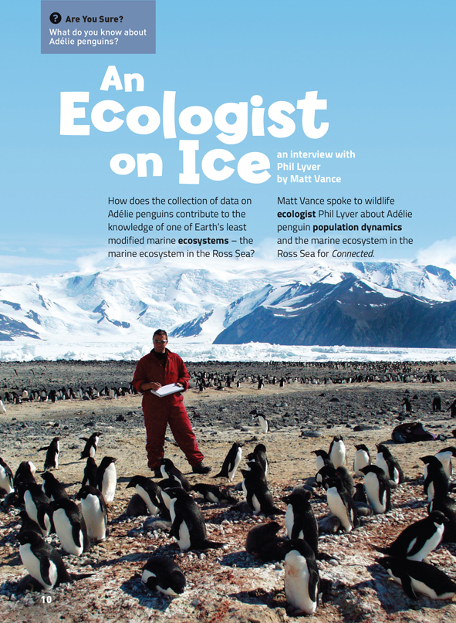  A Google Slides version of this article is available at www.connected.tki.org.nz.
Science capability  Students need to develop a set of capabilities that support them to ask informed questions if they are to participate as “critical, informed, responsible citizens in a society in which science plays a significant role”. The capabilities enable students to meet the achievement objectives in a way that supports the purpose of science in The New Zealand Curriculum and the development of the key competencies. These capabilities include being ready, willing, and able to gather and interpret data. Students need to understand what counts as evidence in science, the importance of observation, and the difference between observation and inference. |  |  |  |  | Text characteristics  - Abstract ideas and concepts, and lengthy sections of explanatory text  - Illustrations, photographs, text boxes, a diagram, and a map containing main ideas that relate to the text’s content  - Scientific vocabulary and terminology.

Curriculum context
SCIENCE
NATURE OF SCIENCE: Understanding about science  Achievement objective(s)  L4: Students will identify ways in which scientists work together and provide evidence to support their ideas.  NATURE OF SCIENCE: Investigating in science  Achievement objective(s)  L4: Students will ask questions, find evidence, explore simple models, and carry out appropriate investigations to develop simple explanations. |  | LIVING WORLD: Participating and contributing  Achievement objective(s)  L4: Students will use their growing science knowledge when considering issues of concern to them.  L4: Students will explore various aspects of an issue and make decisions about possible actions.  LIVING WORLD: Ecology  Achievement objective(s)  L4: Students will explain how living things are suited to their particular habitat and how they respond to environmental changes, both natural and human-induced. |  |  |  | Key Nature of Science ideas  - Science knowledge is based on direct, or indirect, observations of the natural physical world.  - Scientists gather data, using their senses to make observations.  - Making careful observations often involves measuring something.  - Observations are influenced by what you already know.  - Scientists use their observations to build models (including computer generated and mathematical models) that they use to test their ideas and help to explain and predict possible outcomes.  Key science ideas  - All living things belong to an ecosystem – an interacting system of living things.  - Changes in the environment and human-induced factors can have an effect on living things.  - Scientists gather data to understand the relationship between different parts of the ecosystem and to investigate the impact of change.

ENGLISH
READING  Ideas  L4: Students will show an increasing understanding of ideas within, across, and beyond texts. |  | INDICATORS  - Makes meaning of increasingly complex texts by identifying and understanding main and subsidiary ideas and the links between them.  - Makes connections by thinking about underlying ideas within and between texts from a range of contexts.  - Recognises that there may be more than one reading available within a text.  - Makes and supports inferences from texts with increasing independence. |  |  |  | THE LITERACY LEARNING PROGRESSIONS  The literacy knowledge and skills that students need to draw on by the end of year 8 are described in The Literacy Learning Progressions.

Scientific investigation
A science investigation where you change or try something and observe what happens is called an experiment. Not all scientific investigations are experiments; there are many ways of investigating in science. The New Zealand Curriculum science achievement aims indicate that students should experience a range of approaches to scientific investigation including classifying and identifying, pattern seeking, exploring, investigating models, fair testing, making things, and developing systems. Many scientific investigations involve systematic observation over time of an object, an event, a living thing, or a place.  Some important things to remember when you do a scientific investigation are: to be systematic and fair; to make sure that only one thing is changed at a time if you are doing an experiment or fair test so you are sure which changes result in which outcome; to observe and record what happens very carefully; and to be open minded so you notice things you are not expecting. |  |  |  | Sound data is obtained when you are able to get similar outcomes each time you do the same thing, or when data has been collected in the same way and in a systematic manner. No investigation or experiment results in a “wrong” outcome. You may have done something differently from others or the conditions may be slightly different so you don’t get the same result as others do, but it is not “wrong”.  Thinking about and developing explanations about why things happen the way they do, based on evidence, is an important aspect of science. Another important aspect is critically evaluating methods and ideas. Part of a scientist’s work is critiquing and evaluating the methods and ideas of other scientists. They expect their work to be subject to critique. If they are going to be able to make informed decisions about scientific issues as responsible citizens, students first need to experience a range of approaches to scientific investigation and to practise critique and evaluation of scientific methods and ideas – both their own and those of others – just like scientists do!

Meeting the literacy challenges

The following strategies will support students to understand, respond to, and think critically about the information and ideas in the text. After reading the text, support students to explore the key science and technology ideas outlined in the following pages.  TEXT CHARACTERISTICS  - Abstract ideas and concepts, and lengthy sections of explanatory text  - Illustrations, photographs, text boxes, diagrams, maps, charts, and graphs, containing main ideas that relate to the text’s content  - Scientific vocabulary and terminology. |  | TEACHER SUPPORT  Want to know more about instructional strategies? Go to:  http://literacyonline.tki.org.nz/Literacy-Online/Teacher-needs/Pedagogy/Reading#Years5-8  http://literacyonline.tki.org.nz/Literacy-Online/Student-needs/National-Standards-Reading-and-Writing  http://www.literacyprogressions.tki.org.nz/  “Working with Comprehension Strategies” (Chapter 5) from Teaching Reading Comprehension (Davis, 2007) gives comprehensive guidance for explicit strategy instruction in years 4–8.  Teaching Reading Comprehension Strategies: A Practical Classroom Guide (Cameron, 2009) provides information, resources, and tools for comprehension strategy instruction.

INSTRUCTIONAL STRATEGIES
FINDING THE MAIN IDEAS  IDENTIFY aspects of the structure, such as the title, headings, text boxes, and photographs, that will help students to navigate the article.  PROMPT the students to make connections to their prior knowledge by locating Antarctica on a world map and then locating the Ross Sea.  After scanning the article, the students will have noticed that the article records an interview with an ecologist working in Antarctica and that the subject of the ecologist’s research is penguins. PROMPT the students to ask questions of the text and to RECORD their answers as they read.  - What are the questions you would ask Phil Lyver?  When they have finished reading, DISCUSS whether they found all the answers to their questions and whether any new questions have arisen.  PROMPT the students to identify and respond to the text’s message.  - What does Phil mean by “live in a respectful relationship with nature”? (page 17) What is your response to this statement? |  | USING DESIGN FEATURES FOR DEEPER UNDERSTANDING  PROMPT the students to make connections across the text, including the information in the photographs, to help make meaning.  - What can you learn, simply by looking at the photographs? What do the photographs tell you that the words don’t?  Ask questions to support the students to use the food web diagram on page 12 and integrate information as they are reading.  - What do you know about the use of arrows to show connections in a diagram? Why do the arrows point away from the creatures that is eaten and towards the creatures that eats it? [This is because a food web shows how “energy” (in the form of food) moves though the chain.]  - Why do you think this diagram has been included in the article?  DEALING WITH SCIENTIFIC VOCABULARY  IDENTIFY the scientific words that may challenge students, for example, “bioindicators”, “natural variation”, “incubate”, and “obligate species”.  Ask questions to support the students to use their prior knowledge and the clues in the text to find the meanings of unfamiliar vocabulary.  - What is an ecologist? What parts of the word help you to make a prediction about the meaning of this word?  - The terms “response variable” and “predictor variable” are defined in the glossary, but before looking there, try reading the text on page 15 to see if you can find the meaning there. What examples are shown? What other examples of response and predictor variables can you think of from our previous work in science? See if you can write a simple definition before reading the one in the glossary.
  Our questions | What we found out

Teacher support
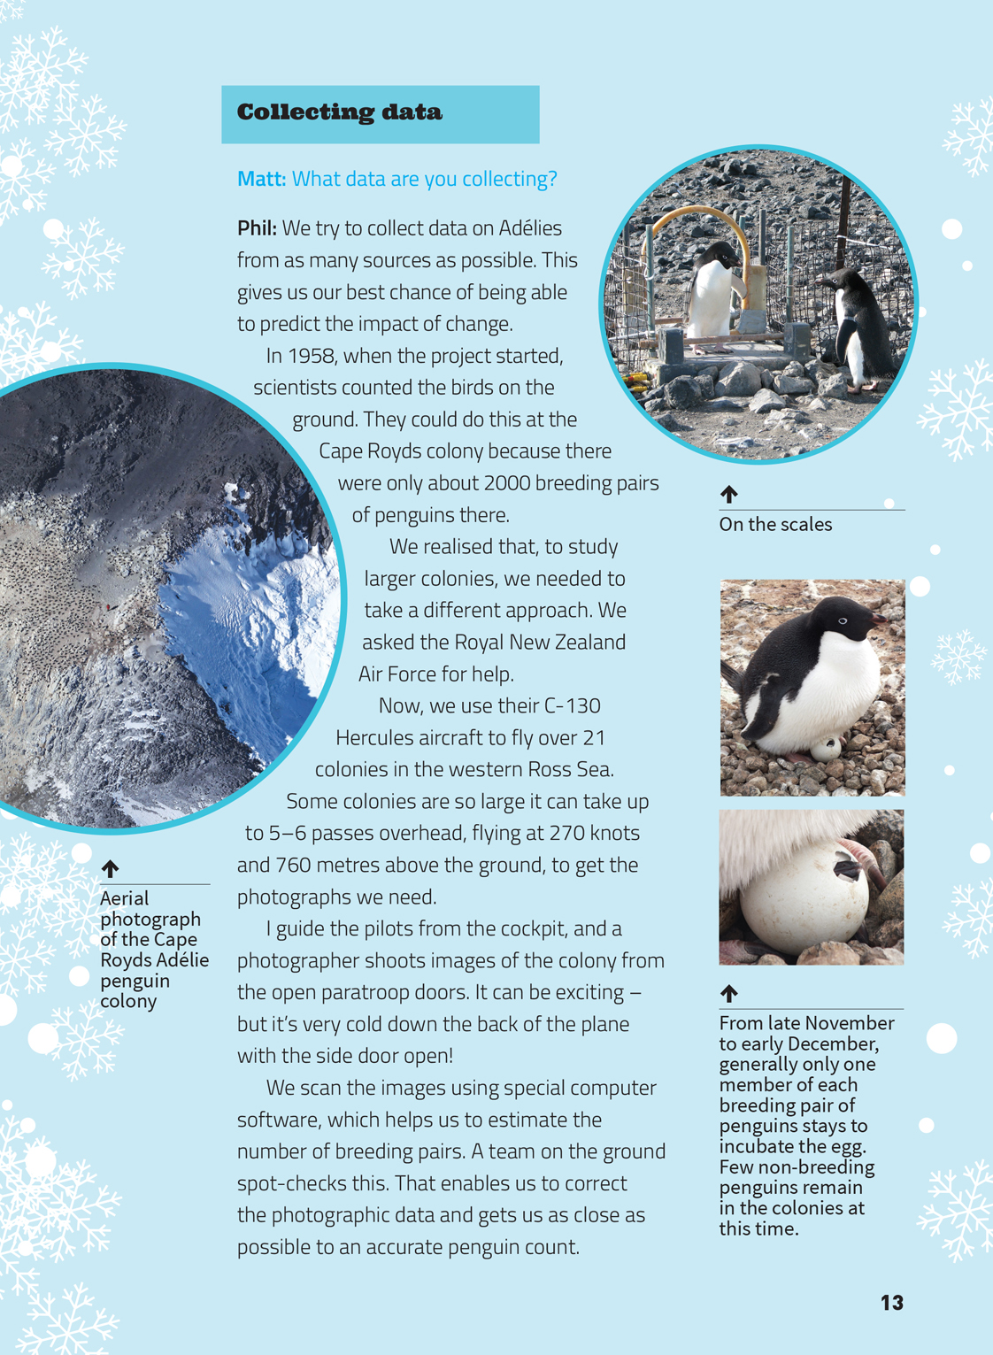 | Making careful observations often involves measuring something.  Scientists gather data to understand the relationship between different parts of the ecosystem and investigate the impact of change.  New technology can provide more comprehensive and accurate data that can challenge previous findings.
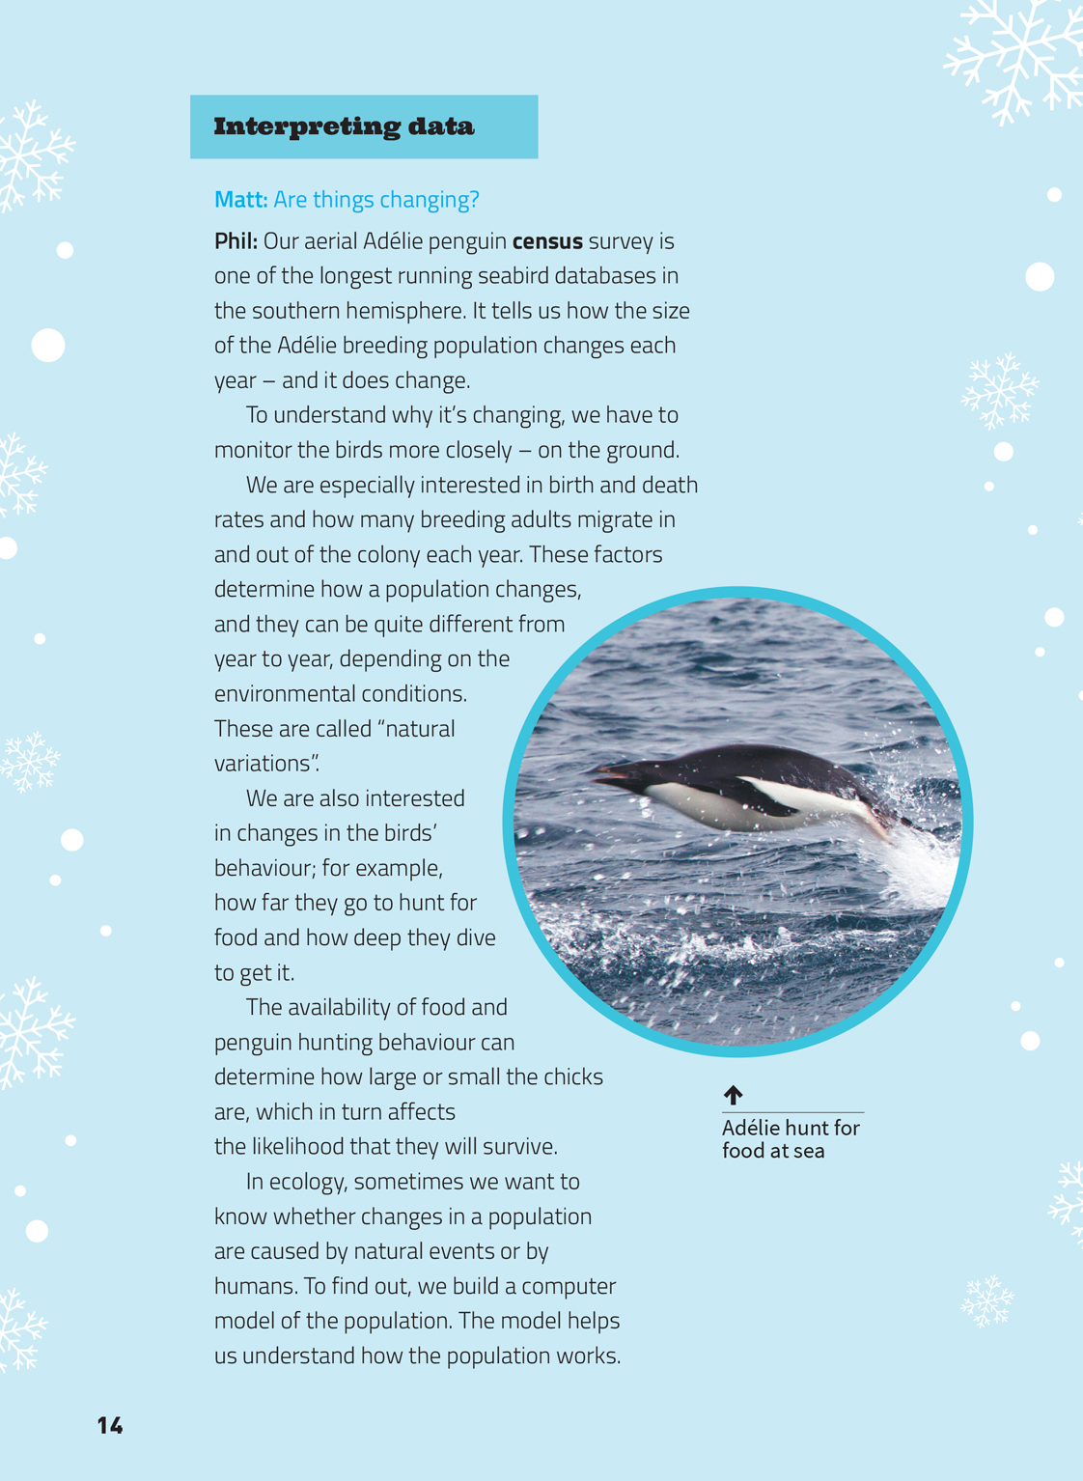 | Changes in the environment and human-induced factors can have an effect on living things.  Scientists explore various aspects of an issue to inform decisions about possible actions.  Scientists use their observations to build models that they use to test their ideas. They use models to explain and predict possible outcomes.

Exploring the science
Some activities focus directly on the science capability of “gathering and interpreting data” and the Nature of Science strand. Other activities extend student content knowledge. You are encouraged to adapt these activities to make the focus on Nature of Science explicit and to support students to develop the capability to collect and interpret data.
LEARNING FOCUS |  | KEY SCIENCE IDEAS
Students make observations, gather data, and interpret and discuss outcomes based on their observations. |  | Key Nature of Science ideas  - Science knowledge is based on direct, or indirect, observations of the natural physical world.  - Scientists gather data, using their senses to make observations.  - Making careful observations often involves measuring something.  - Observations are influenced by what you already know.  - Scientists use their observations to build models (including computer generated and mathematical models) that they use to test their ideas and help to explain and predict possible outcomes.  Key science ideas  - All living things belong to an ecosystem – an interacting system of living things.  - Changes in the environment and human-induced factors can have an effect on living things.  - Scientists gather data to understand the relationship between different parts of the ecosystem and to investigate the impact of change.
LEARNING ACTIVITIES

Activity 1: Monitoring change
To find out more about why and how scientists monitor animal populations, have the students read “A Helpful Immigrant”. This Connected article discusses the heather beetle and how to count the estimated number of beetles, and examines the use of this data to ensure imported organisms are doing the work they are supposed to do and not having any unintended adverse effects.
The students can then go on a Learnz virtual field trip to Charleston, near Westport, to find out about the seasonal monitoring of little blue penguins/kororā and seals. The trip will give them the opportunity to:
- get up close to penguin chicks, seal pups, and their penguin and seal parents
- use technology, such as a burrow scope
- take part in daily and seasonal conservation work
- carry out a population count and apply estimation techniques
- “catch” a one-year-old seal pup
- get close to a blue penguin/kororā chick
- find out the life stories of pups and chicks
- assess the health of individual animals by taking measurements and samples, then process and interpret the data
- explore the rocky shore and discover what makes up the local food chains
- discover the reasons why penguins and seals are under attack from local and global threats, what steps are being taken to conserve them, and what they can do to help
- relate our marine life to local and global issues, such as sustainability, climate change, food webs, water, interconnectedness, the land/sea interface, and human activity.

Activity 2: Digging deeper
If students still have questions following their reading, they could conduct further research using the links suggested on page 8 in this TSM.
If this has not already been addressed, ask the students to describe how and why the way scientists count penguins has changed since counting began in 1958. How has technology helped?
Look at the online census information about the Adélie penguin, and compare the population of penguins from a specific region over a period of time. How has the population changed? Investigate and discuss reasons for any major changes.

Activity 3: Food web
The diagram on page 12 illustrates part of a food web – a model of the feeding relationships in a community. Food webs (or food chains) can be used to communicate the concept that living things in a community interact with each other and that disruption at one point in the web will disrupt the rest of the web.
Use the Science Online page on food chains for information on how to construct and understand them. Encourage the students to ask questions to investigate a Ross Sea marine food web and the place of Adélie within it. The focus might be on interpreting a more detailed diagram of a food web and making statements as a result of reading the data, or it might be on constructing a more elaborate diagram to represent what the students have found out. Note that while Adélie sit near the top of the Ross Sea marine food web, they are themselves eaten by leopard seals, skua, and orca, among other predators.
The students could then use what they have learnt to construct a food chain or web for where they live.
- What is the “apex predator”?
- What is a “response variable” you might investigate to identify how they are doing? What “predictor variables” in your local environment may affect this?
“Who Eats Whom?” in Making Better Sense of the Living World (page 115) provides suggestions for how students could construct a food chain for a local pond. It also points out that the reality of feeding relationships is usually more complex than a simple chain, with one creature being the prey for a variety of other creatures. For this reason, a food web can be more appropriate.

Extension
If you haven’t already done so, have the students view the NIWA video and use it as a prompt for discussing what would happen if one of the items in the food web were removed.
You could use the webbing game in Making Better Sense of the Living World (page 116) as a way to prompt thinking about the impact of a range of scenarios on the organisms in an environment.

Activity 4: Lessons for the world
The setting of Antarctica in the article was chosen for its unique environment and ecology. Explore why this is and what make scientists so interested in exploring it. Working in groups, they could focus on different aspects, for example:
- the unique challenges of working in the Antarctic environment and how these are addressed
- the unique opportunities it presents to a scientist, including the fact that it provides a relatively unspoilt environment for research
- the technology that scientists are using and how this has changed over time
- the discoveries that have been made possible through the introduction of a particular scientific technique, such as ice core sampling
- the impact of humans on the Antarctic environment.
Have each group consider the lessons that can be learnt from this work and design an appropriate way to communicate these lessons to others.

Activity 5: The effects of change
Building Science Concepts, Book 22 – Tidal Communities: Interdependence and the Effects of Change provides the opportunity to explore the interactions between living things on the costal shore. It is a context that also provides the opportunity to explore Māori values associated with kaimoana, interdependence, and the idea of kaitiakitanga (people’s responsibilities as guardians of their environment).

Activity 6: Taking action
Students could find out about and, if possible, take part in, ecological monitoring projects. Forest and Bird runs events to help people observe and protect local wildlife through its Kiwi Conservation Club (KCC).
The KCC site includes the example of a local initiative that was successful in protecting the Hutton’s shearwater, a seabird that was under threat from wild pigs preying on its eggs. Students could read the article and then find out about other seabirds that are at risk and ways their school could help to protect and support monitoring programmes.
Students could monitor pests around the school, their homes, or in local nature reserves by making and using tracking tunnels, as described on the KCC site. They could then collect and interpret the data, consider the relative threats to wildlife, and explore what can be done about pests in these areas.
The Department of Conservation site has material about humpback whales, including its monitoring programme and how people can help. A video clip shows how ex-whalers are now helping to protect the whales.

Google Slides version of “An Ecologist on Ice” www.connected.tki.org.nz

RESOURCE LINKS

Making Better Sense of the Living World: “Who Eats Whom?” and “The Webbing Game” (pages 115–116)
Building Science Concepts, Book 22 – Tidal Communities: Interdependence and the Effects of Change
Learnz: Penguins and Seals – Seasonal Monitoring of Chicks and Pups http://www2.learnz.org.nz/core-fieldtrips.php
Science Learning Hub www.sciencelearn.org.nz/Contexts/Icy-Ecosystems and www.sciencelearn.org.nz/Science-Stories/Research-Voyage-to-Antarctica
Science Online Constructing Diagrams of Food Chains http://scienceonline.tki.org.nz/Nature-of-science/Nature-of-Science-Teaching-Activities/Constructing-diagrams-of-food-chains
Landcare Research: Adélie Census Data http://www.landcareresearch.co.nz/resources/data/adelie-census-data
UC Plus Science Outreach (Birds/food Web) www.outreach.canterbury.ac.nz/chatham/resources
Cool Antarctica: Antarctica Fact File http://www.coolantarctica.com/Antarctica%20fact%20file/antarctica%20fact%20file%20index.htm
Adaption to the Cold www.anta.canterbury.ac.nz/resources/adapt.html
Antarctic Marine Food Webs http://www.niwa.co.nz/video/antarctic-marine-food-webs
NIWA: Marine Diversity http://www.niwa.co.nz/education-and-training/schools/resources
University of Canterbury: Food Webs http://www.outreach.canterbury.ac.nz/chatham/resources/resources_5.shtml
Zealandia: Food Webs www.visitzealandia.com/education/year-1-10-activities/
Forest and Bird: Kiwi Conservation Club http://www.kcc.org.nz/events
Shearwater http://www.kcc.org.nz/huttons-shearwater-success-story
Department of Conservation http://www.doc.govt.nz/conservation/native-animals/marine-mammals/whales/humpback-whales/
“A Helpful Immigrant” Connected 3, 2011
“Who’s Eating Who?” Connected Level 4, 2012

