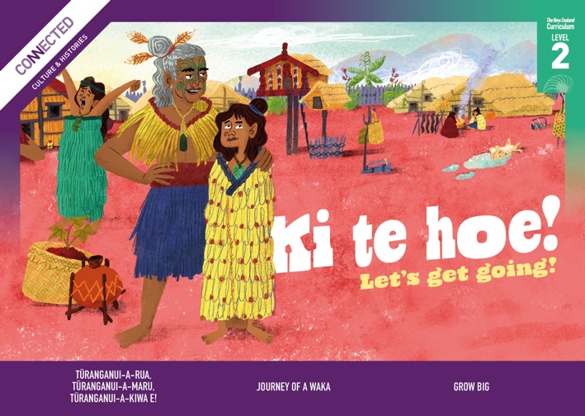

Level 2, 2022

Overview
This Level 2 Connected resource explores themes of first arrivals in Aotearoa New Zealand, the naming of places, journeying by waka across the Pacific, and the cultivation of kūmara. It focuses on changes to the name of Tūranganui-a-Kiwa/Poverty Bay; on the skills, preparation, and knowledge needed to traverse the Pacific by waka; and on life in a papakāinga in the 1700s.

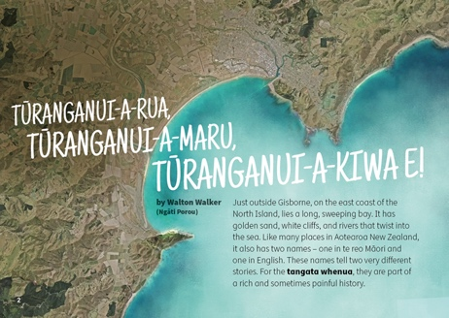  Tūranganui-a-Rua, Tūranganui-a-Maru, Tūranganui-a-Kiwa e!  by Walton Walker (Ngāti Porou)  Place names are historical records that commemorate important events from our past, connect us to our ancestors, and shape our collective sense of identity. In 2019, Poverty Bay officially changed its name to Tūranganui-a-Kiwa/Poverty Bay – a significant moment for the local iwi who had long campaigned for returning the original name. Tūranganui-a-Kiwa translates as “the long waiting place of Kiwa” – Kiwa being one of the original Polynesian navigators who discovered the area. This article explores the rich history behind the names of this area through arrival stories and the recent decision to use a dual name. | 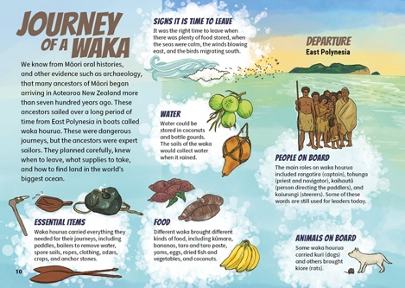  Journey of a Waka (infographic)  This infographic shows how the tūpuna of Māori skilfully and deliberately navigated to Aotearoa New Zealand from East Polynesia over seven hundred years ago. The lists include who was on board and their roles, how they survived during the voyage, how they navigated, and what they brought with them.  The Google Slides version of this article has additional digital content to extend ākonga learning. | 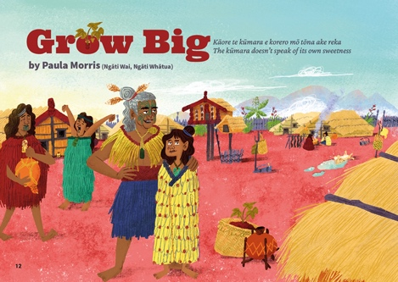  Grow Big  by Paula Morris (Ngāti Wai, Ngāti Whātua)  This fictional story is intended to give young readers a picture of life in a kāinga through the eyes of a child. The story is set in a northern village in Te Ao Tawhito (the old world) around 1770. It is a gentle story with lots of details to help readers get a sense of daily life at the time.

Potential inquiry questions
- What stories do hapū and iwi tell about their whakapapa and their voyaging and exploration?
- How do place names reflect the identities of people in the area?
- How did the environment in Aotearoa New Zealand influence the tikanga and cultural identity of Māori who settled here?
- How do iwi and hapū stories of migration and voyaging in your area differ from or resemble other iwi and hapū stories? How do these similarities and differences reflect various iwi and hapū identities?
- How do stories of migration and voyaging help us understand people’s identities?

ANZH curriculum overview (years 4–6)
Understand  big ideas | Know  contexts |  | Do  inquiry practices
- Māori history is the foundational and continuous history of Aotearoa New Zealand.  - Colonisation and settlement have been central to Aotearoa New Zealand histories for the past two hundred years.  - The course of Aotearoa New Zealand’s histories has been shaped by the use of power.  - Relationships and connections between people and across boundaries have shaped the course of Aotearoa New Zealand’s histories. | Whakapapa me te whanaungatanga ǀ Culture and identity  This context focuses on how the past shapes who we are today – our familial links and bonds, our networks and connections, our sense of obligation, and the stories woven into our collective and diverse identities.  For years 4–6 ākonga, the focus is on:  Māori voyaging through the Pacific was deliberate and skilful and brought with it Pacific whakapapa and cultural identities. These identities were transformed over the centuries through adaptations to and relationships with the environment and through the formation of hapū and iwi that eventually occupied Aotearoa New Zealand.  Tūrangawaewae me te kaitiakitanga ǀ  Place and environment  This context focuses on the relationships of individuals, groups, and communities with the land, water, and resources, as well as on contests over their control, use, and protection.  For years 4–6 ākonga, the focus is on:  People adapted their technologies and tools to the new environment of Aotearoa New Zealand. |  | When exploring these histories, I will be developing  practices to:  - construct a historical sequence of related events and changes, show how long ago they happened, and say how other people might construct the sequence differently  - use historical sources, giving deliberate attention to mātauranga Māori sources, to gather evidence to answer my questions about the past, as well as identifying views that are missing and note how this might affect my answers  - identify the attitudes and values that motivated people in the past and compare them with attitudes and values today.
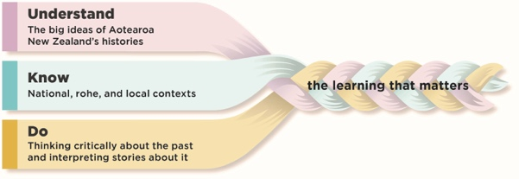  To find out more about the Understand, Know, Do framework, go to https://aotearoahistories.education.govt.nz/content-overview |  | Using this resource  This resource provides examples of how you might use the three texts in this Connected to design learning experiences by weaving together the Understand, Know, Do elements of the Aotearoa New Zealand histories content.  These activities are designed to build ākonga understanding of the practices that support them to think critically about the past and interpret stories about it. You can select from the activities depending on the needs of and relevance for your ākonga.  The activities suggest ways ākonga can think critically about texts to build their knowledge and develop their understanding of the big ideas. The texts can contribute to ākonga-led inquiries into the stories told about the people, events, and changes that have been important in the local area.  The activities can help ākonga to understand that our knowledge of history comes from many sources including historical fiction, which uses real events as the basis for imaginative and interpretive explorations of the past.

Literacy skills at this level  Ākonga use a range of specific literacy skills to develop their understanding of history, engage with historical concepts, and communicate historical understandings.  - See the Literacy Learning Progressions: Meeting the Reading and Writing Demands of the Curriculum  - For significant signposts in reading and writing, see the Learning Progression Frameworks  - Note that for each text, there are links to the relevant aspect of the Learning Progression Frameworks (Reading).  The Refresh of the New Zealand Curriculum is replacing the Learning Progression Frameworks and Literacy Learning Progressions by incorporating the learning for literacy & communication into the curriculum learning area progressions. To learn more about the refresh visit Refreshing The New Zealand Curriculum.  When engaging with level 2 history texts, ākonga use their growing literacy expertise to:  - follow a sequence in fiction and non-fiction history texts using common cohesive devices (words or phrases used to connect ideas between different parts of text)  - retell a story about the past  - generate questions before, during, and after reading  - find and evaluate information to answer specific questions about the past  - think critically about ideas, events, and people in the texts they read, making comparisons between the past and the present.  - use their developing knowledge of the structure, language, and features of common text types to navigate and understand history texts  - identify the purpose of a text  - use their growing vocabulary knowledge to work out unfamiliar words and phrases  - find and retrieve information from charts, graphs, maps, and diagrams.  Depending on the needs and literacy expertise of your ākonga, and the prior knowledge they bring about the topic, you may choose to share-read the texts with the whole class or small groups or use a mixture of guided and shared reading with small groups. Some ākonga may be able to read the text independently or in pairs after initial guidance and an introduction from you. Audio can also be used for ākonga who require more support and who would benefit from rereading the text. | It may be helpful to have ākonga preview the text, noting particular features and making predictions about the content and purpose. Before reading, you may decide to explore with ākonga some of the specialised vocabulary, te reo Māori, place names, or words and phrases that are not explained by the context or the glossary.  Activating prior knowledge  Before reading a story or article, activate the prior knowledge of ākonga to help them fully engage with the text. There are many ways you might do this. For example:  - Share a key image on a screen and have ākonga discuss what it shows (what, when, where, why, and who).  - Devise a questionnaire on a relevant topic you are focusing on in the text. Have ākonga discuss their answers in pairs and then share with the class. Create a class chart of current knowledge that can be challenged, changed, or confirmed throughout the inquiry.  - Have ākonga begin a KWLQ chart and complete the chart when they finish the text.  Prompt ākonga to share ways to think critically about a source, for example, by asking questions about its purpose, audience, perspective, and relationship to other sources. The National Library provides a useful tool for evaluating primary sources.  Connecting with your local histories  - Explore names and stories that relate to your region, examining which place names and stories are prominent and which have been largely forgotten.  - Investigate stories that local iwi and hapū share about the history of the people of this rohe and explore new ways to make these stories known in your school and the wider community.  - For guidance on exploring the Māori history of your rohe, see pages 3–4 of Te Takanga o te Wā – Māori History Guidelines for Years 1–8 and Leading Local Curriculum Guide – Part 1.  Your ākonga bring their own perspectives and experiences to these histories. They may have personal and emotional connections with and reactions to some of the histories. Be aware of this in your planning and use the critical inquiry practices to support safe and respectful conversations. (See also Leading Local Curriculum Guide – Part 2 and content on the Aotearoa New Zealand’s Histories website.)

Tūranganui-a-Rua, Tūranganui-a-Maru, Tūranganui-a-Kiwa e!  by Walton Walker (Ngāti Porou) | Key concepts  Tangata whenua tell stories about their origins and arrival. Naming places was a key way Māori established mana and tūrangawaewae. One of the consequences of colonisation is the need to work together to re-establish the original names of places. | Author biography  Walton Walker (Ngāti Porou) is the Chairperson of the Ngā Taonga o Ngā Tama Toa Trust and is involved in many parts of the Gisborne community. | 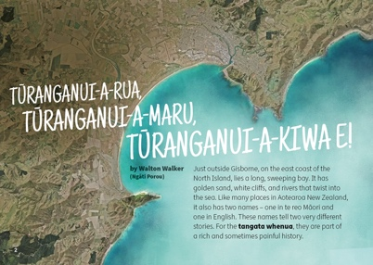

Literacy demands of the text
This text has links to the following aspects of the Learning Progression Frameworks (Reading):
- Making sense of text: using knowledge of text structure and features
- Making sense of text: reading critically
- Acquiring and using information and ideas in informational texts.
The signposts on each of these aspects provide detail about what to notice as your ākonga develop their literacy knowledge and skills for different purposes in different curriculum areas. The text also provides opportunities for ākonga to develop and use the knowledge and skills outlined in the Literacy Learning Progressions “by the end of year 4”.
This text requires ākonga to navigate several text types and features, including the arrival and naming story, a historical account of Cook’s arrival and renaming of the area as Poverty Bay, a mōteatea, sidebars providing additional or related information, and visual information including maps and photos. Draw ākonga attention to the various text structures and features during a preview of the text. This will help them make connections across the text to understand what led to the naming of Poverty Bay, including the actions of Gisborne schoolchildren to reclaim its Māori name, Tūranganui-a-Kiwa, and the impact and importance of this change for tangata whenua.
Some ākonga may find the timeframe challenging. Support them to develop a timeline of the key stages described in the article and have them describe the events at each stage to make sure they understand the sequence.

Connecting with your local histories
Ākonga can explore how names in their rohe reflect the arrival stories of different groups and explore the experiences of people who arrived on the Horouta and people who arrived in their rohe later.

Background information for kaiako
- Tūranganui-a-Kiwa tribes – Te Ara Encyclopedia of New Zealand
- Tūranganui-a-Kiwa/Poverty Bay – Toitū Te Whenua Land Information New Zealand
- Te Runanga o Tūranganui-a-Kiwa: Representing the interests of Rongowhakaata, Ngai Tamanuhiri, and Te Aitanga A Mahaki – TROTAK Home Page
- Cook’s map of Aotearoa New Zealand – The National Library of New Zealand

Related texts
- ​“Sixth Sense” – School Journal Level 2, August 2018
- “A Hoe!” – School Journal Level 2, June 2018
- “Tupaia: Master Navigator” – School Journal Level 3, August 2019

Big Ideas

The activities that follow all support understanding the four big ideas: Māori history, colonisation and settlement, the use of power, and relationships – for example:
- Māori arrived in Aotearoa New Zealand a very long time ago, and the Māori who encountered those on the Endeavour were the descendants of tūpuna who arrived on various waka from Hawaiki.
- Cultures use naming to express identity, connection, and ownership. Names often link back to key people “at home” or aspects of the journey.
- Places in Aotearoa New Zealand had names given by iwi and hapū.
- Settlers often renamed places with names that meant something to them without permission from local iwi.
- Restoring the original Māori name for a place is a way of acknowledging the history of tangata whenua and their relationship with a place.

Tūranganui-a-Rua, Tūranganui-a-Maru, Tūranganui-a-Kiwa e!

Activities

Developing a sense of time and place
In this activity, ākonga use the articles alongside other sources to deepen their understanding of Māori history, colonisation, and power by exploring what life was like for:
- various people on the waka Horouta
- various people on the Endeavour
- Māori who encountered the people on the Endeavour.
Provide ākonga with a range of sources exploring the experiences of people on the two sailing vessels and allow them time to role play scenes from their journeys, for example, “Tupaia: Master Navigator” from SJ Level 3, August 2019; “Te Kuri” story from Tupapa; “Captain Cook: Charting our Islands” from SJ Level 4, May 2016; “The Cook’s Cook” by Gavin Bishop; this YouTube video about life on the Endeavour.

Exploring place names
Revisit the text and extract the parts referring to the two names. Ask ākonga:
- Why were these events important enough to remember them through the names?
- Whose views and perspectives were missing from these namings?
- How do people’s identities today reflect these events?
When talking about power, colonisation, and identity, think carefully about the experiences and identities that ākonga bring to the discussion.

Names in your rohe
In this activity, ākonga explore ways that place names can help us understand what was important to people at the time of naming.
Reread the text to find evidence for naming practices that reflect arrival stories, for example, “for the tangata whenua, the name connects them to their tūpuna” (page 8). This shows that a naming practice could involve the name of a person who is important in the whakapapa of the people who live there today. Generate a list of naming practices together, then determine how the names of their area demonstrate that practice.
Work with ākonga to research place names in your rohe, or go for a neighbourhood walk to find out the names of streets, parks, and other locations in your local area. Ākonga may like to research important arrival events or people who featured in arrival stories in their area and recommend these as names to be used in the future – for example when new streets are named or for areas in their school. There might be interesting stories. There may also be traumatic stories. Before doing this, learn about these histories, know your students, and prepare to support how they might experience these stories.

Drawing comparisons
In this activity, ākonga ask and answer questions about the people on the Horouta waka and the Endeavour.
- Where did they come from?
- Why did they leave?
- What was their voyage like?
Compare the attitudes and motivations of a person or group on the Endeavour or the Horouta with the attitudes and motivations of people migrating today.
Journey of a Waka  (infographic)  The Google Slides version of this article has additional digital content to extend ākonga learning. | Key concepts  Māori voyaging through the Pacific was deliberate and skilful and brought with it Pacific whakapapa and cultural identities. These identities were transformed over the centuries through adaptations to and relationships with the environment and through the formation of hapū and iwi that eventually occupied and claimed all of Aotearoa New Zealand. | 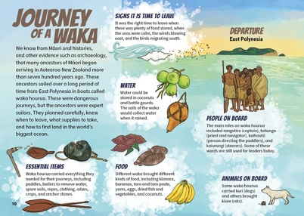

Literacy demands of the text
This text has links to the following aspects of the Learning Progression Frameworks (Reading):
- Making sense of text: using knowledge of text structure and features
- Making sense of text: vocabulary knowledge
- Making sense of text: reading critically
- Acquiring and using information and ideas in informational texts.
The signposts on each of these aspects provide detail about what to notice as your ākonga develop their literacy knowledge and skills for different purposes in different curriculum areas. The text also provides opportunities for ākonga to develop and use the knowledge and skills outlined in the Literacy Learning Progressions “by the end of year 4”.
This infographic requires ākonga to interpret visual information and its organisation. Ākonga may require support to understand and use topic-specific vocabulary related to food, equipment, birds, animals, and activities.
Other demands lie in the need to apply different strategies for reading the infographic. For example, the reader could start anywhere, information is conveyed in various ways including lists and sentences, and overall meaning and understanding is gained from combining words, pictures, and symbols.
Support ākonga to identify the main structure and organisation of the text. Remind them that asking questions is a good strategy for understanding and interpreting an infographic. Model questions or have them ask their own to figure out the meaning of the infographic.
For example:
- What is the purpose of this infographic? What does it show? What helps you to know that?
- Where do we start reading? Does it matter?
- What information is presented in the boxes? Why is it presented this way?
- What do we learn from the left side and the right side?
- What does each part represent? What information does each part contain? How do all the parts work together?
- Who might have created this infographic? Who is it created for?
- Why do you think the information was presented this way?
- What can we learn about the journeys of Māori tūpuna to Aotearoa New Zealand from this infographic?

Connecting with your local histories
Ākonga could explore which of the items brought over survived in their rohe.

Background information for kaiako
- Pacific voyaging and discovery – NZ History
- Pacific migrations – Te Ara Encyclopedia of New Zealand
- Pacific origins – Te Ara Encyclopedia of New Zealand
- Adapting to new lands and climate – Te Ara Encyclopedia of New Zealand

Related texts
- “Explorers of the Sunrise” – School Journal Story Library, Level 4, 2014
- “Kurī” – School Journal Level 2, October 2015
- “The Past Beneath Our Feet” – School Journal Level 3, May 2016
- “The Long Pause” – Connected Level 3, 2019

Big ideas
The activities that follow all support understanding the four big ideas: Māori history, colonisation and settlement, the use of power, and relationships – for example:
- Both oral histories and archaeology show that the ancestors of Māori began arriving in Aotearoa New Zealand long ago and were the first people on these islands.
- The tūpuna of Māori came to Aotearoa New Zealand in different groups at different times, bringing a variety of resources including kūmara.
- These tūpuna were expert navigators who used a variety of signs from the natural world to navigate skilfully across the Pacific ocean and to find land.
- The tūpuna planned carefully and voyaging waka were well prepared for their journeys.

Activities

Activating prior knowledge
Ask ākonga to draw a picture of one of the waka that brought the first people to Aotearoa New Zealand. Encourage them to include the people, the animals, and the items that would have been carried on the waka.

Climate
In this activity, ākonga will explore some similarities and differences between Aotearoa New Zealand and Pacific countries and use these to predict how the first people to arrive in Aotearoa New Zealand may have needed to adapt to the climate.
Ask ākonga to carefully read the infographic and ask:
- Why do you think some crops didn’t survive?

Journey of a Waka
Ākonga can then consider some reasons why crops might not survive in different locations and create their own historical questions related to this.
Compare climate tables from your area in Aotearoa New Zealand and a Pacific Island.
Show ākonga a globe and explain how countries closer to the equator have warmer climates and usually have only two seasons: wet and dry. Ask them to think about how plants grow and note down the conditions that plants from nearer the equator would grow in compared with plants in Aotearoa New Zealand. Use these ideas to write statements explaining why certain plants survived and others didn’t.
To deepen ākonga understanding of how some of their classmates may have had to move to Aotearoa New Zealand, ask ākonga to role play how it might feel to arrive in Aotearoa New Zealand and experience our different climate, sequencing the events for preparing to leave, leaving their homelands, travelling, and arriving. Then ask:
- How might the first people in Aotearoa New Zealand have needed to adapt their way of life?
Ākonga could show their learning by writing a diary entry or historical fiction text based on planning for the journey, travelling to Aotearoa New Zealand, arriving, and building a life here.

What was brought on the waka journeys?
In this activity, ākonga will investigate what the first people in Aotearoa New Zealand brought with them and compare that with what they would take on a similar journey now.
Ask:
- How would people know about the new place?
- How would they know how long the journey would take?
Ask ākonga to categorise the items brought on the waka to create criteria for what they would take. They may create criteria such as food to eat on the journey, food to grow when you get there, tools, materials for shelter, and materials for clothing.
Ask ākonga to create a list of what they would take if their family was going to migrate somewhere and had to take everything they needed. Then place the items on their lists into the categories from the waka journeys. Are they missing any categories? Are there items on their list that don’t fit any of the categories? Use these differences to make some predictions about the differences between the lives and values of the people who journeyed to Aotearoa New Zealand on the waka and ākonga in the class.

Grow Big  by Paula Morris (Ngāti Wai, Ngāti Whātua) | Key concepts  Traditional Māori economies were finely tuned to the resources within each rohe, which provided the basis for trade between iwi. | Author biography  Paula Morris (Ngāti Wai, Ngāti Whātua) is an award-winning fiction writer and teaches creative writing at the University of Auckland. | 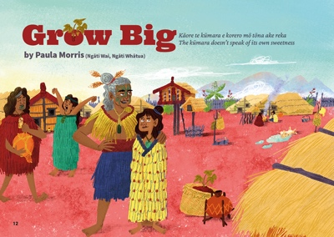

Literacy demands of the text
This text has links to the following aspects of the Learning Progression Frameworks (Reading):
- Making sense of text: using knowledge of text structure and features
- Making sense of text: reading critically.
The signposts on each of these aspects provide detail about what to notice as your ākonga develop their literacy knowledge and skills for different purposes in different curriculum areas. The text also provides opportunities for ākonga to develop and use the knowledge and skills outlined in the Literacy Learning Progressions “by the end of year 4”.
This story requires ākonga to recognise that the narrative conveys information about the tikanga involved in growing and cultivating kūmara. Te reo Māori is used throughout the text and is explained within or glossed at the bottom of the page.
Another demand requires ākonga to track the events and conversations across the text to interpret and understand the meaning of the whakataukī at the end of the story.
Remind ākonga to think about the purpose of the text (fiction with a historical setting) and to record information about the growing of kūmara as they read, either by themselves, with a partner, or in a group. They may find it helpful to generate questions before and during reading and discuss what they found out after the reading, comparing kūmara growing in the 1770s and today.

Connecting with your local histories
Ākonga could explore kūmara growing and origin stories in their rohe and what kāinga looked like.

Background information for kaiako
- Kūmara – Te Ara Encyclopedia of New Zealand
- Te mahi kai: Food production economics – Te Ara Encyclopedia of New Zealand
- What is the Maramataka – the Māori lunar calendar?
- What Is the Difference Between the Lunar Calendar & the Solar Calendar?
- Māori arrival and settlement – Te Ara Encyclopedia of New Zealand
- Māori: The First 500 years – RNZ/The Aotearoa History Show
- Move over astrology, it’s time to return to the Māori lunar calendar – The Spinoff

Related texts
“Whakaotirangi and her Kete of Kūmara” – Connected Level 2, 2020
“Garden with Science” – Connected Level 2, 2014
Pōpō! He Reo Mōteatea – TKI

Big Ideas
The activities that follow all support understanding the four big ideas: Māori history, colonisation and settlement, the use of power, and relationships – for example:
- Maramataka were the first calendar systems used in Aotearoa New Zealand. Different rohe have different maramataka, depending on the stars that are visible at a given time.
- Kūmara arrived in Aotearoa New Zealand with Māori and the climate here made it a more important food source than in Hawaiki. This influenced the development of Māori identity and culture.
- Māori adapted their ways of growing kūmara for the climate of Aotearoa New Zealand.
- With European colonisation the maramataka was widely replaced with the Gregorian calendar.
- Māori culture, traditions, and practices are not static but change over time.

Activities

Activating prior knowledge
Ask ākonga to draw a child their age who lived in Aotearoa New Zealand in the 1700s.
Think about:
- What would their house look like?
- What would be around their house?
- What people would they live with or near?
- What animals would there be?
- What would they wear?
- What would they eat?
Alternatively, ākonga could find historical images using the National Library Topic Explorer, New Zealand History, or DigitalNZ. Have ākonga share their observations, thoughts and feelings, and questions about the images they find. The National Library’s “Explore a photo” tool provides a useful model.
See also: Teaching tips: Using historical images

Maramataka
In this activity, ākonga deepen their understanding of Māori history and colonisation by exploring the maramataka (the Māori lunar calendar) and the Gregorian calendar to understand the people who created and who use them.
Ask ākonga to read the story again and note down any words that relate to months or seasons.
Teach ākonga a waiata maramataka that uses the names of the lunar months from your rohe. This common waiata includes the transliterated terms for the English months.
Display this poster: Takurua Winter, Koanga Spring, Raumati Summer, Ngahuru Autumn. Ask ākonga to match up any words they saw in the text with those in the waiata they just learnt. Ask why the words on the poster have two English months in brackets next to them. Draw out the possibility that it’s because the two kinds of months (the maramataka and the Gregorian) aren’t exactly aligned and explain that the te reo months are based on the maramataka and the English months are based on the Gregorian calendar.
Explain that some people suggest we use transliterations, for example, Hānuere – when referring to solar months in te reo and the maramataka words when referring to lunar months.
Then ask:
- Why would there be two different calendars?
- Who might have made the maramataka?
- Who might have made the Gregorian calendar?
- Each calendar is based on a celestial body – which do they think the lunar calendar is based on? Can they guess what the Gregorian calendar is based on?
- When have they seen or used the Gregorian calendar?
- When have they seen or used the maramataka?
Discuss the differences between the Gregorian calendar and the lunar calendar – that one is based on the sun and the other on the moon. Discuss why some groups used the sun rather than the moon to create their calendar.
Ākonga may like to explore this clip about a school that is basing its calendar on maramataka.
See page 7 of Mānawatia a Matariki: Celebrating Matariki for information about the maramataka and transliterations of solar months.

Kūmara
In this activity, ākonga deepen their understanding of Māori history by exploring origin stories of kūmara.
Display this quote from Te Ara (https://teara.govt.nz/en/kumara/page-1):
“In Polynesia, kūmara grows all year round, and is propagated by planting the shoots from the edible part of the vegetable. In New Zealand, however, winter is too cold to grow kūmara – and even in summer it will not grow in some areas. Also, kūmara has to be grown from tubers instead of from shoots.”
Ask ākonga to read the story again and note down the parts that explain how kūmara was grown. Ask them to predict how the first people in Aotearoa New Zealand might have adapted their methods of growing kūmara when they arrived. Ākonga could research different methods of growing kūmara and create a Venn diagram showing the similarities and differences.
Ākonga could explore kūmara origin stories or whakataukī from a variety of iwi and hapū. They could compare the different origin stories and make statements about what they show about the values of the iwi and hapū. Then they could watch this short documentary about a Chinese New Zealand couple who recognised the importance of kūmara: https://vimeo.com/176253524. Ākonga could then compare the importance of kūmara today with its importance in the past.
These links provide further exploration:

Grow Big
- Hine Hakirirangi – East Coast region – Te Ara Encyclopedia of New Zealand
- Stories – Arrival in Aotearoa New Zealand – Tupapa
- The Moeraki Boulders/Kaihinaki – Canoe traditions – Te Ara Encyclopedia of New Zealand

Investigating Moka’s kainga
In this activity, ākonga deepen their understanding of Māori history by using the setting of the story as a historical source to suggest what a kāinga like Moka’s might have looked like.
Prompt ākonga to read the story in groups and take notes about any aspect of the text or illustrations that would help them recreate the kāinga.
Explain that we use many sources to get pictures of history. Imagining and writing historical fiction helps us fill in the gaps and relate to people’s lives at different times.
Guide them to use other sources, such as these:
- Kāinga – Māori settlement – Te Ara Encyclopedia of New Zealand
- Model of a Māori village and Pā – Museum of New Zealand Te Papa Tongarewa
 | My prediction | Ideas from the story | Other reasons for my prediction
Natural features in and around the kāinga | There is a stream downhill from the whare. | Page 14 says “Climbing back up the hill was hard work” and describes Moka coming back with water. | The stream wouldn’t be too far away because they would have to go there every day to get water.
Buildings
Gardens
People
Animals
- Kāinga – DigitalNZ
- Māori housing – te noho whare – Te Ara Encyclopedia of New Zealand
Use a table like the one below to guide their planning. Encourage ākonga to think about the shape, materials, numbers, and so on of the items.
Choose a method for ākonga to create their model. For example, they may like to use Minecraft, clay, card, or drawings. Ask ākonga to annotate their models with information that will help people understand what the kāinga would have been like.

Grow Big

Sharing the learning
In this activity, ākonga communicate their learning in creative ways to help other people understand the past.
Ākonga research pre-European life in their area and write a diary entry or short story from the perspective of a child at the time, using “Grow Big” as a model.

