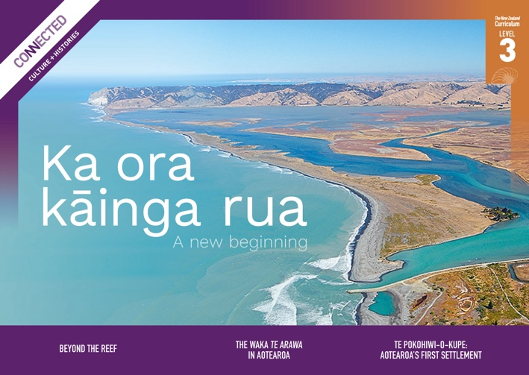

Level 3, 2022

Overview

This Level 3 Connected resource explores themes of identity, migration, whakapapa, early settlements in Aotearoa New Zealand, and archaeology. It focuses on the reasons Moriori left Hawaiki, the landing sites of the waka Te Arawa in Aotearoa New Zealand, and the thriving early settlement established at the Wairau Bar.
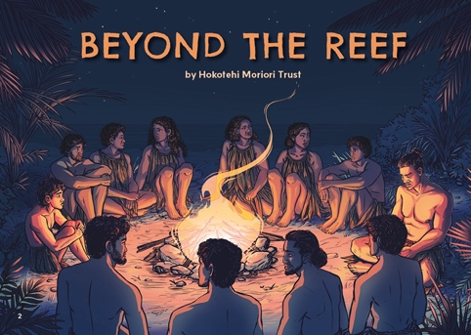  Beyond the Reef  by Hokotehi Moriori Trust  This story recounts some of the events that contributed to Moriori migration from East Polynesia to Rēkohu/Chatham Islands. The story of Riʻi is written by the Hokotehi Moriori Trust and is based on oral histories that have been handed down over hundreds of years. The story reveals the seeds of the covenant of peace that Moriori would make after settling Rēkohu. | 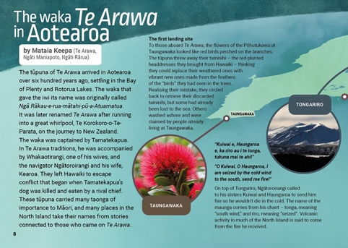  The Waka Te Arawa in Aotearoa  This infographic illustrates some of the landing sites of the waka Te Arawa in Aotearoa New Zealand. It outlines stories associated with each landing site and places that were named by people on the waka. It also describes objects and taonga that were brought on the waka such as kūmara and taininihi. | 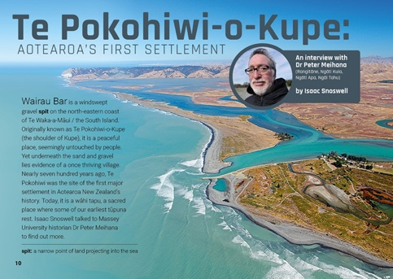  Te Pokohiwi-o-Kupe: Aotearoa’s First Settlement  An interview with Dr Peter Meihana (Rangitāne, Ngāti Kuia, Ngāti Apa, Ngāi Tahu) by Isaac Snoswell  Wairau Bar is one of the earliest settlement sites in Aotearoa New Zealand. Seven hundred years ago, it was home to a village of at least two hundred people, serving as a hub for trade, celebrations, ceremonies, and community. This interview with Dr Peter Meihana explores who lived there, when they arrived, where they came from, what the settlement was used for, and how we know this.  The Google Slides version of this article has additional digital content to extend ākonga learning.

Potential inquiry questions
- How do migration stories and experiences shape our identities as New Zealanders?
- What stories do different groups tell about their migration?
- What skills are needed to adapt to a new country or environment?
- How has our understanding of early migrations changed over time?

ANZH curriculum overview (years 4–6)
Understand  big ideas | Know  contexts |  | Do  inquiry practices
- Māori history is the foundational and continuous history of Aotearoa New Zealand.  - Colonisation and settlement have been central to Aotearoa New Zealand histories for the past two hundred years.  - The course of Aotearoa New Zealand’s histories has been shaped by the use of power.  - Relationships and connections between people and across boundaries have shaped the course of Aotearoa New Zealand’s histories. | Whakapapa me te whanaungatanga ǀ Culture and identity  This context focuses on how the past shapes who we are today – our familial links and bonds, our networks and connections, our sense of obligation, and the stories woven into our collective and diverse identities.  For years 4–6 ākonga, the focus is on:  Māori voyaging through the Pacific was deliberate and skilful and brought with it Pacific whakapapa and cultural identities. These identities were transformed over the centuries through adaptations to and relationships with the environment and through the formation of hapū and iwi that eventually occupied Aotearoa New Zealand.  Tūrangawaewae me te kaitiakitanga ǀ  Place and environment  This context focuses on the relationships of individuals, groups, and communities with the land, water, and resources, as well as on contests over their control, use, and protection.  For years 4–6 ākonga, the focus is on:  People adapted their technologies and tools to the new environment of Aotearoa New Zealand. |  | When exploring these histories, I will be developing practices to:  - construct a historical sequence of related events and changes, show how long ago they happened, and say how other people might construct the sequence differently  - use historical sources, giving deliberate attention to mātauranga Māori sources, to gather evidence to answer my questions about the past, as well as identifying views that are missing and note how this might affect my answers  - identify the attitudes and values that motivated people in the past and compare them with attitudes and values today.
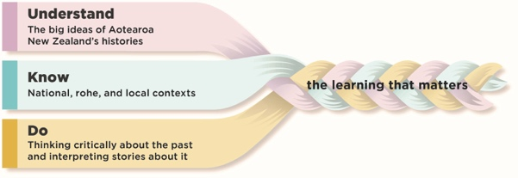  To find out more about the Understand, Know, Do framework, go to https://aotearoahistories.education.govt.nz/content-overview |  | Using this resource  This resource provides examples of how you might use the three texts in this Connected to design learning experiences by weaving together the Understand, Know, Do elements of the Aotearoa New Zealand histories content.  These activities are designed to build ākonga understanding of the practices that support them to think critically about the past and interpret stories about it. You can select from the activities depending on the needs of and relevance for your ākonga.  The activities suggest ways ākonga can think critically about texts to build their knowledge and develop their understanding of the big ideas. They can help ākonga to understand that our knowledge of history comes from many sources including historical fiction, which uses real events as the basis for imaginative and interpretive explorations of history. The texts can contribute to ākonga-led inquiries into the stories told about the people, events, and changes that have been important in the local area.

Literacy skills at this level  Ākonga use a range of specific literacy skills to develop their understanding of history, engage with historical concepts, and communicate historical understandings.  - See the Literacy Learning Progressions: Meeting the Reading and Writing Demands of the Curriculum  - For significant signposts in reading and writing, see the Learning Progression Frameworks  - Note that for each text, there are links to the relevant aspect of the Learning Progression Frameworks (Reading).  The Refresh of the New Zealand Curriculum is replacing the Learning Progression Frameworks and Literacy Learning Progressions by incorporating the learning for literacy & communication into the curriculum learning area progressions. To learn more about the refresh visit Refreshing The New Zealand Curriculum.  When engaging with level 3 history texts, ākonga use their growing literacy expertise to:  - identify a historical sequence in fiction and non-fiction history texts and think critically about different interpretations  - generate relevant questions about the past, gather evidence during reading to answer those questions, and identify missing information  - identify a writer’s purpose and how information has been deliberately conveyed  - identify what information is missing and consider why this might be  - think critically about ideas, events, and people in the texts they read, making comparisons between the past and the present  - use a range of text features and structures, along with their prior knowledge, to interpret historical concepts and abstract ideas  - identify whose voice is represented in a text and whose voices are missing  - use their expanding vocabulary knowledge to work out unfamiliar words and phrases, particularly the topic-specific and specialised language of history texts  - interpret and link information from charts, graphs, maps and diagrams, text boxes, and photos with the main ideas and purpose of the text.  Depending on the needs and literacy expertise of your ākonga and the prior knowledge they bring, you may choose to share-read the texts with the whole class or small groups or use a mixture of guided and shared reading with small groups. | Other strategies such as jigsaw or reciprocal reading may be helpful for particular texts. Some ākonga may be able to read the text independently or in pairs after initial guidance and an introduction from you. Audio can also be used for ākonga who require more support and who would benefit from rereading the text.  It may be helpful to have ākonga preview the text, noting particular features and making predictions about the content and purpose. Before reading, you may decide to explore with ākonga some of the specialised vocabulary, te reo Māori, place names, or words and phrases that are not explained by the context or the glossary.  Activating prior knowledge  Before reading a story or article, activate the prior knowledge of ākonga to help them fully engage with the text. There are many ways you might do this. For example:  - Share a key image on a screen and have ākonga discuss what it shows (what, when, where, why, and who). See Teaching tips: Using historical images for more suggestions.  - Devise a questionnaire on the topic. Have ākonga discuss their answers in pairs and then share with the class. Create a class chart of current knowledge that can be challenged, changed, or confirmed throughout the inquiry.  - Have ākonga begin a KWLQ chart and complete the chart when they finish the text.  Prompt ākonga to share ways that historians might approach a source, for example, by asking questions about its purpose, audience, perspective, and relationship to other sources. The National Library provides a useful tool for evaluating primary sources.  Connecting with your local histories  - Explore the migration stories of well-known people and organisations in your rohe, focusing on how people’s places of origin shape their identities.  - Explore ways that ideas and values passed down over time shape the identity of communities in your rohe.  - Investigate the Māori history of your rohe and explore new ways to make these stories known in your school and the wider community.  - For guidance on exploring the Māori history of your rohe, see pages 3–4 of Te Takanga o te Wā – Māori History Guidelines for Years 1–8 and ANZH Leading Local Curriculum Guide – Part 1.  Your ākonga bring their own perspectives and experiences to these histories. They may have personal and emotional connections with and reactions to some of the histories. Be aware of this in your planning and use the critical inquiry practices to support safe and respectful conversations. (See also Leading Local Curriculum Guide – Part 2 and content on the Aotearoa New Zealand’s Histories website.)

Beyond the Reef  by Hokotehi Moriori Trust | Key concepts  Moriori voyaging through the Pacific was deliberate and skilful and brought with it Pacific whakapapa and cultural identities. | Author biography  Hokotehi Moriori Trust is an organisation that represents Moriori people – the descendants of Rongomaiwhenua and Rongomaitere – on the islands of Rēkohu and Rangihaute (Chatham Islands), in New Zealand, and elsewhere. | 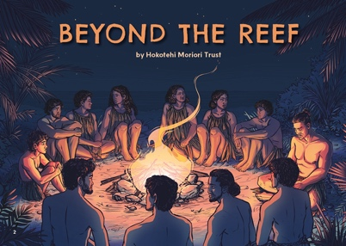

Literacy demands of the text
This text has links to the following aspects of the Learning Progression Frameworks (Reading):
- Making sense of text: using knowledge of text structure and features
- Making sense of text: reading critically
- Reading for literary experience.
The signposts on each of these aspects provide detail about what to notice as your students develop their literacy knowledge and skills for different purposes in different curriculum areas. The text also provides opportunities for students to develop and use the knowledge and skills outlined in the Literacy Learning Progressions “by the end of year 6”.
The main literacy demand of this text is the changing time sequence. The story begins in the present, then shifts to the past to describe events several months earlier before returning to the present again. Remind students to notice and use the time-sequence markers such as “Last month …”, “In the days that followed …”, and “Later that night ...” to identify the flashback and follow the sequence of events. Prompt students to notice tense changes as these also provide clues about the time shifts.
Another literacy demand is the growing anxiety Ri‘i experiences as his family prepares to leave their home. Making connections with the anguish Ri‘i feels in leaving his home and his best friend will support students to empathise with the emotions many people experience when they migrate to a new land.
Some students may find the story’s timeframe challenging. Support them to develop a timeline of the key events described in the text, and have them describe the events at each stage to make sure they understand the sequence.

Background information for kaiako
Moriori are the waina pono (indigenous people) of Rēkohu (Chatham Islands). They arrived at Rēkohu from East Polynesia, but it is also thought that a later wave of migration had contact with a place called Aote (thought to be Aotearoa New Zealand).
Central to Moriori culture and identity is a peace covenant made over six hundred years ago that forbids the taking of human life. The commitment to follow a path of peace endures to this day.
In 1835, Rēkohu was invaded by around nine hundred Taranaki Māori (Ngāti Mutunga and Ngāti Tama). Nearly one-sixth of the Moriori population was killed and the rest enslaved.
In 1862, Moriori petitioned Governor Grey for the return of their lands, but their request was not granted. In 1870, a Native Land Court ruling gave over 97 percent of the land to Ngāti Mutunga. Moriori were left landless and robbed of the right to live as Moriori in their own land.
Since the 1970s, Moriori have worked collectively to rebuild their culture and identity, including the revitalisation of ta rē Moriori (the Moriori language) and the opening of Kōpinga Marae. The status of Moriori as tchakat henu (tangata whenua) of Rēkohu was formally recognised by the Crown in 2019. In 2020, a Deed of Settlement agreeing redress for Treaty claims was signed by Moriori and the Crown, including an apology from the Crown.

Links and related texts
- Deed of Settlement of Historical Claims
- Moriori: Still setting the record straight
- Moriori Claims Settlement Bill 2020: Bills Digest 2634
- “The Long Pause”, Connected Level 3, 2019, Shifting Views.

Big ideas
The activities that follow all support understanding the four big ideas: Māori history, colonisation and settlement, the use of power, and relationships. For example:
- Moriori voyaged from East Polynesia to Rēkohu over several waves of migration and were the first inhabitants of the island.
- Moriori made a peace covenant long ago, before their arrival at Rēkohu. The covenant is an enduring part of Moriori identity and culture.
- That not all ancestors of Moriori agreed to the peace covenant, and this was one of the reasons some groups left East Polynesia in search of a new home.

Activities

Prereading activity
Find out what students already know about Moriori history and culture, by asking:
- What do you know about Moriori people and culture?
- Where is the henu/whenua of Moriori?
- Where is Rēkohu?
- What are some connections between Rēkohu and mainland Aotearoa New Zealand?
There have been some myths in Aotearoa New Zealand about Moriori, many of which came about through errors in how Moriori history was taught in schools. These myths include:

Beyond the Reef
- Moriori became extinct after 1933.
- Moriori were cast out of Aotearoa New Zealand by Māori.
- Moriori were weak and inferior because of their decision not to fight.
Learning about Moriori history provides an opportunity to address these myths. The following resources provide helpful information for teachers to ensure that the information they are presenting to students is evidence-based:
- Setting aside the Moriori myth
- Moriori: Still setting the record straight
- Moriori Claims Settlement Bill 2020: Bills Digest 2634
- Hokotehi: Moriori unity and development
- Education resources for unit plans, unit plan templates
- Moriori (Moriori YouTube channel)

Reasons for and experiences of migration
In this activity, students develop their understanding of the reasons why Ri‘i’s family left their homeland, and they use this to interpret how migration has influenced Moriori identity today.
After reading the text, use a three-level guide like the one below to encourage students to think about the reasons Ri‘i’s family left their homeland. Students should decide whether each statement is true or false according to the story and use evidence from the text to support their answers. Adapt the statements to suit the needs of your students. Have them share their responses in pairs or groups before discussing the answers as a class.

Level 1: Literal understanding of what is happening
- Ri‘i’s family has been fighting with Moe’s family.
- The fighting started when Horopapa’s daughter, Pāpā, was killed.
- Ri‘i’s family doesn’t want Moe’s family to know they are leaving.
- Horopapa wants the people on the island to return to the time of peace.
- Pāpā was killed when the sacred meeting house was burnt down.

Level 2: Inferring what is happening
- This story happened a long time ago.
- The fighting on the island had been going on for a long time.
- The preparations for the journey are guided by tikane/tikanga.
- Ri‘i is concerned about leaving in secret and about leaving his best friend.
- Horopapa is too old to make the journey and wants to remain in his homeland.
- The villagers used to live peacefully together.

Level 3: Applying the information in the story
There isn’t necessarily a right or wrong answer for these statements – the point is to debate both sides.
- When people migrate, there are both push factors (reasons to leave a particular place) and pull factors (reasons to go to a particular place).
- People migrating today often have similar attitudes and values to Ri‘i’s family.
- Resolving conflicts peacefully is only possible if everyone involved agrees.
- Sharing stories about where we come from shapes our identities.

Alternative statements for Level 3:
- Ri‘i’s family made a good decision to leave in secret.
- Moe and Ri‘i might see each other in the future.
- The story shows how important peace is to Ri‘i’s whānau.

Reasons for migration
In this activity, students identify the reasons why Ri‘i’s family left their homeland in East Polynesia and travelled towards Rēkohu and interpret how these have shaped Moriori identity today.
Ask students to reread the story to find out the reasons Ri‘i’s family left their homeland. When they have identified the fighting, deaths, and the burning of the sacred meeting house, use the “five whys” technique to identify potential causes of the departure. In “five whys”, the answer to each question forms the basis of the next question. This is repeated to give five questions starting with why – this allows students to explore the deeper causes of an event.
Ask students to reread page 3, where Horopapa’s dream is described. Discuss why large birds might be a factor that would entice Ri‘i’s family to move there.

Beyond the Reef

A people of peace
In this activity, students use “five Rs of significance” to determine the significance of the events described in the story in relation to:
- how events in this story reflect potential origins of the Moriori pact to be peaceful
- the role of Nunuku’s law in Moriori history and identity.

Display the “five Rs” of significance:
- Remembered: The event/development was important at some stage in history within the collective (shared) memory of a group or groups.
- Resulting in change: It had consequences for the future.
- Revealing: It reveals some other aspect of the past.
- Remarkable: The event/development was remarked on by people at the time and/or since. It could also be unusual, beyond the realm of normal life, or unexpected.
- Resonant: People like to make analogies with it; it is possible to connect with experiences, beliefs, or situations across time and space.
Discuss each of the “five Rs” and how students can investigate whether an event is remembered, resulted in change, revealing, remarkable, or resonant.
In small groups, students can research Nunuku’s law and choose one of the “five Rs” to determine how significant they think the events in the story are. This site has a short video and written information that can guide students in their research.
Groups can then share their findings and discuss the significance of these events as a class.

The Waka Te Arawa in Aotearoa  (infographic) | Key concepts  The names of different waka play an important role in Māori stories of origin, arrival, and identity. | 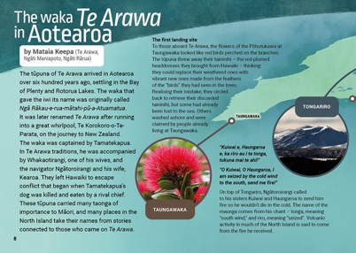

Literacy demands of the text
This text has links to the following aspects of the Learning Progression Frameworks (Reading):
- Making sense of text: using knowledge of text structure and features
- Making sense of text: reading critically
- Reading to organise information and ideas for learning
- Acquiring and using information and ideas in informational texts.
The signposts on each of these aspects provide detail about what to notice as your ākonga develop their literacy knowledge and skills for different purposes in different curriculum areas. The text also provides opportunities for ākonga to develop and use knowledge and skills outlined in the Literacy Learning Progressions “by the end of year 6”.
The presentation and organisation of the information in this infographic present the main literacy demands for ākonga. They will need to recognise the progression of information map to understand where the waka Te Arawa travelled once it arrived in Aotearoa New Zealand. They will also need to integrate information from the maps with the text boxes to understand more about which iwi they are associated with, and the key landing sites of Te Arawa. It may be helpful to pose the following questions or have ākonga ask their own questions as they discuss and interpret the meaning of the infographic:
- What is the purpose of this infographic? What are the big ideas it is conveying? What helps you to know that?
- Where do we start reading? Does it matter where we start?
- What are the parts of the infographic? What information do they contain? How do they work together as a whole?
- What information has been left out? What doesn’t the infographic show?
- Who might have created this infographic and who was it created for?
- Why do you think the information was presented this way? How effective is this way of presenting information?
- What can we learn about Te Arawa waka from this infographic?

Connecting with your local histories
Ākonga can explore local landing sites and find out which waka their local iwi and hapū descend from.

Background information for kaiako
- Waka landing places – Ngā waewae tapu – Māori exploration – Te Ara Encyclopedia of New Zealand
- Ngā waewae tapu – Māori exploration – Te Ara Encyclopedia of New Zealand
- Tupapa: Our stand, our story

Related texts
- “The Long Pause”, Connected Level 3, 2019
This article explores the mystery of the long pause between the two major periods of Pacific migration. It demonstrates how the science of archaeology can be used to explain and understand the world and how scientists provide evidence to support ideas.
- “Whakaotirangi and Her Kete of Kūmara”, Connected Level 2, 2020
This article tells how Whakaotirangi brought kūmara and other plants to Aotearoa and describes the techniques she used to plant, grow, and store them.

Big ideas
The activities that follow all support understanding the four big ideas: Māori history, colonisation and settlement, the use of power, and relationships. For example:
- The ancestors of Māori voyaged to Aotearoa New Zealand in several waves.
- Iwi and hapū whakapapa to different waka, and many iwi and hapu take their names from these waka or tūpuna who arrived on them.
- Places in Aotearoa New Zealand have names given by iwi and hapū and connected to oral histories about various tūpuna.
- Cultures use naming to express identity, connection, and ownership. Names often link back to key people “at home” or aspects of the journey.

Activities

Reading the infographic
In this activity, the focus is on exploring the movements of the first people to come to Aotearoa New Zealand.
Show ākonga the Te Arawa waka landing sites infographic. Discuss the following as a class:
- What parts of the motu did they land in?
- Why do you they think they landed there?
Ākonga can look at the current names for the landing sites and compare these with the ones on the infographic, and they can look at the journey the waka took and infer where they think the waka may have come from.

How many waka came from Hawaiki?
In this activity, ākonga think critically about the narratives that are told about the past by examining the once commonly held belief that there were only seven migratory waka and that these arrived together in a single great fleet.
Play ākonga the song “Nga Waka e Whitu”, which can be found on YouTube or Spotify.
Explain that this song is from the 1960s but was still being used in schools up to the 1990s.
Ask ākonga to write down the names of the waka they hear in the song.
Ākonga can then read the following pages to learn about the myth of the great fleet, how iwi oral histories tell us where different waka went, and why they think some stories are different from others.
- Coastal explorers – Te Ara Encyclopedia of New Zealand
- Canoe traditions – Te Ara Encyclopedia of New Zealand
Ākonga could explore the waka connected to their local area.

What happened next?
In this activity, the focus is on researching a group’s experiences and writing a creative text to describe an event from that group’s perspective.
Choose one waka and explore these questions:
- Where did the waka land?
- Which iwi whakapapa to that waka?
- Where did the various iwi and hapū from that waka travel?
- Why do you think they travelled away from the original landing site?
Show the whakapapa of the waka Te Arawa to the class from this page: Whakapapa from the Te Arawa canoe – Tauranga Moana. Ensure that ākonga know that many iwi were named after tūpuna. Some of these tūpuna arrived on the waka, while some were descendants of people who arrived in the waka.
In small groups, ask ākonga to choose a group of people from one waka and research what those people did after their waka arrived, including which iwi and hapū descend from that waka.
Ākonga can then research a significant place from their rohe and retell the stories connected with that place.

The Waka Te Arawa in Aotearoa

Te Pokohiwi-  o-Kupe: Aotearoa’s First Settlement  An interview with Dr Peter Meihana (Rangitāne, Ngāti Kuia, Ngāti Apa, Ngāi Tahu) by Isaac Snoswell  The Google Slides version of this article has additional digital content to extend ākonga learning. | Key concepts  Māori voyaging through the Pacific was deliberate and skilful and brought with it Pacific whakapapa and cultural identities. These identities were transformed over the centuries through adaptations to and relationships with the environment. Traditional Māori economies were finely tuned to the resources within each rohe. | Author biography  Dr Peter Meihana (Ngāti Kuia, Rangitāne, Ngāti Apa, Ngāi Tahu) is a senior lecturer in Māori history at Massey University. He is also a trustee of Te Rūnanga a Rangitāne o Wairau. | 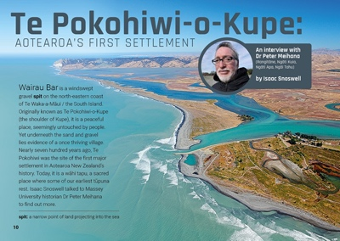

Literacy demands of the text
This text has links to the following aspects of the Learning Progression Frameworks (Reading):
- Acquiring and using information and ideas from informational texts
- Making sense of text: vocabulary knowledge
- Making sense of text: using knowledge of text structure and features.
The signposts on each of these aspects provide detail about what to notice as your ākonga develop their literacy knowledge and skills for different purposes in different curriculum areas. The text also provides opportunities for ākonga to develop and use knowledge and skills outlined in the Literacy Learning Progressions “by the end of year 6”.
The main literacy demands of this text are found in the history-related language Dr Meihana uses to interpret archaeological evidence. This language and most te reo Māori words are glossed, while the meanings of others can be inferred or predicted through word knowledge and context.
Ākonga will need to keep track of the detail and explanations Dr Meihana provides. The questions as headings provide a focus for reading, and connecting phrases help link ideas and explanations. The use of radiocarbon dating and DNA to link artefacts with Pacific Islands may be conceptually challenging for some ākonga. They could work in pairs to further explore these concepts.

Connecting with your local histories
Ākonga can explore archaeological sites in their rohe and find out how taonga from their area are cared for. See Teaching tips: Engaging with the GLAM sector (Galleries, Libraries, and Museums) for more suggestions.

Background information for kaiako
- Wairau rich in histories that confirm connections between Māori and Pacific tūpuna – Manatū Taonga
- Wairau Bar: How it all began – RNZ
- Light cast on lifestyle and diet of first New Zealanders
- Myth of Mangahawea: How scientists uncovered the home of our earliest Polynesian arrivals – NZ Herald

Related texts
- “The Past Beneath Our Feet” – School Journal Level 3, May 2016
- “Puawai Cairns: Te Papa Detective” – School Journal Level 3, November 2016

Big ideas
The activities that follow all support understanding the four big ideas: Māori history, colonisation and settlement, the use of power, and relationships. For example:
- Māori were the first people in Aotearoa New Zealand.
- The tūpuna of Māori came to Aotearoa New Zealand in different groups at different times. Their attitudes and values differed from group to group.
- Te Pokohiwi was one of the earliest Māori settlement sites in Aotearoa New Zealand.
- Those living at Te Pokohiwi made use of local resources and developed a rich social, spiritual, and material culture. Evidence suggests they traded taonga up and down the motu.
- The population of Te Pokohiwi varied according to resources available and relationships with other iwi and hapū.
- Māori culture and identity has adapted and changed since the arrival of these tūpuna.
- For decades, artefacts and ancestral remains were taken from Te Pokohiwi by people who didn’t think it was important to consult Rangitāne about their removal.
- Some historians and scientists believed they had the right to take artefacts from other cultures and study and display them.
- Many people now believe that iwi should control what happens to artefacts and ancestral remains.

Te Pokohiwi-o-Kupe: Aotearoa’s First Settlement

Activities

Sequencing the text
In this activity, ākonga deepen their understanding of Māori history by putting the events in this text in order and predicting how each event might have affected the others.
Explain to ākonga that this text describes several different time periods.
Ask them to reread the text and identify the three time periods (the first hundred years of occupation, when artefacts at Wairau Bar were first recovered, and 2010 to the present day). Ask them to draw a table with these headings and place each event described in the text under the appropriate heading.
Ākonga can then choose one event in the earliest time period and make statements about how they caused or influenced the later events.

How did ngā tāngata live here?
In this activity, ākonga use information from the text to find out as much as they can about the lives of the people of Te Pokohiwi.
Have ākonga reread the text to find out as much as possible about how people of Te Pokohiwi might have lived, considering such things as what they ate, where they were born, how they travelled, what their relationships were like, and what work they did.
After ākonga note down what they learnt about ngā tāngata from the text, ask them to identify any gaps in their knowledge. Ākonga could research more about the first people who arrived to fill in those gaps. Ākonga could present this information as a memoir or use role plays to explore the lives of people at Wairau Bar.

Learning from historical artefacts
In this activity, ākonga deepen their understanding of Māori history by considering what we can learn from artefacts found at Te Pokohiwi.
Ask ākonga to reread up to page 12 and note down all the artefacts that were found at Te Pokohiwi. They could then choose some relevant categories these artefacts fit into, for example, kōiwi tangata, tools, food, and remains. Ask them to choose one of the categories and note down what we can learn from this category of archaeological remains, how we find out that information, and what that information tells us about the lives of the first people in Aotearoa New Zealand.

Kaitiaki of historical artefacts
In this activity, ākonga deepen their understanding of colonisation by considering how we should best look after the things that were left behind and who should decide how they are looked after.
Read page 11 and ask:
- How would you feel handling a tool that had been carried to Aotearoa New Zealand in the first waves of migration?
- How is this similar to or different from handling a new tool?
Ākonga could role play finding a historic artefact. Ask them to consider how they would feel, how they would look after it, how they would find out who has the rights to look after and analyse it, and what information they could learn from it. Ask them to put on the role of a different person who was mentioned in the story and predict how they might have felt, how they would like the artefact to be looked after, and what they think we could learn from it.
Ask ākonga to reread page 16 and discuss how they think the artefacts from Te Pokohiwi should be cared for. Discuss whether they think it is fair that artefacts were taken without the permission of the descendants of the tāngata, the Rangitāne iwi, and what they think should be done next.

Adaptations and resources
In this activity, ākonga deepen their understanding of Māori history by exploring why Te Pokohiwi was chosen as a site of settlement and by making comparisons with natural resources in their rohe, such as shelter, fresh water, food, climate, and resources like stone.
Ask ākonga to imagine they are one of the first groups to come to Aotearoa. In small groups, ākonga can write down all the things they think they would need for a good life here, ranking them from most to least important; bringing in the concepts of resources, needs, and wants; and thinking about the attitudes and values of the people who first settled here.
Provide ākonga with a map showing the outline of the Wairau Bar and the surrounding area. Ask them to use information from the text and picture to annotate the map, showing the natural resources such as food, climate, and supplies for tools and shelter. Ākonga could then place the things they decided were important on the map and note down how the features of this area would provide each one.
Ākonga could view historic maps or photographs of settlements near their school and repeat the activity to compare the natural resources of their rohe with Wairau Bar, then make statements explaining how the differences affected the first settlements. For example, they may say that Te Pokohiwi was surrounded by the sea, which gave them easy access to kaimoana, but their own area is inland, so food is harder to find. This meant that fewer people were able to live in their rohe than at Te Pokohiwi.

Respect for kōiwi tangata/burial sites
In this activity, ākonga deepen their understanding of power and colonisation by exploring the attitudes and values shown by New Zealand historians over time.
Read the following text to ākonga:
During the 1930s and 1940s, many Pākehā dug up and sold artefacts found at the Wairau Bar. Hohua Peter MacDonald, mentioned on page 16, said that these activities were desecrating a burial site. He tried to get the status of the area changed to a cemetery, which would prevent people digging there.
Watch this video with ākonga and discuss why repatriation is important to various groups.
Ask ākonga to read the following articles that provide information about the actions of different people during this time. Ākonga could do this as a jigsaw activity in small groups. It is interesting to note that no mention of Rangitāne is made on the Canterbury Museum page.
- Mau kakī (necklace) – Te Papa Tongarewa Museum of New Zealand
- Professionals, academics, and amateurs: 1920s to 1960s – Te Ara Encyclopedia of New Zealand

Te Pokohiwi-o-Kupe: Aotearoa’s First Settlement
- Wairau Bar – Canterbury Museum
- Wairau Bar: How it all began – RNZ
- Rangitāne welcome tupuna home to Wairau Bar in Marlborough – Stuff
- Ancient cooking oven re-excavated at early “capital city” in Marlborough – Stuff
Ask ākonga to make a table with the following headings:
- Person
- Date they were involved with the Wairau Bar
- What they did
- Response to their actions from various groups
- What values or attitudes were shown by their actions.
When they have filled in the table for people involved since the first artefacts were excavated in 1939, using the information from the text and the other articles, they could make some statements about how attitudes and values have changed since the 1940s and 1950s.
- Colonisation and power
- Ensure ākonga understand that Pākehā and government attitudes to historical artefacts have changed over time.

