The Living World: Eat or be Eaten
Adaptations of a Carnivore: A Bird

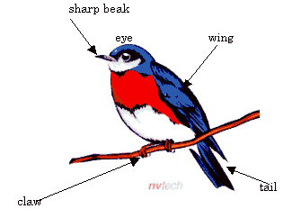
1. The bird has a sharp ________________ which is an adaptation to help it to get food. An animal which eats other animals is called a ________________ .

2. To help it to cling to branches the bird has feet with three _______________ pointing forward and one toe pointing backwards.

3. The ________________ and ________________ are adaptations for flying. The bird has many ________________ over the body which help in flight and also keep the bird ________________.

4. The bird is ________________ so it can easily move through the air.

5. Birds have hollow bones which make them ________________.

6. Some birds eat plant material like ________________ as well as animal material like ________________. An animal which eats both plants and animals is called an ________________.

