The Living World: Eat or be Eaten
Adaptations of a Herbivore: The Caterpillar

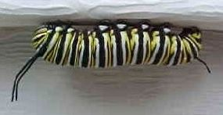

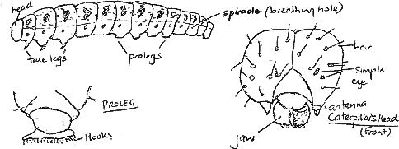

Look at the pictures above and see if you can answer these questions.

1. A caterpillar has chewing ________________ which are an adaptation for eating leaves. An animal which eats plant material is called a ________________.

2. The ________________ legs and prolegs are adaptations which help the caterpillar to ________________ onto plants. The prolegs have ________________.

3. Some caterpillars have ________________ over their body which are sensitive to ________________.

4. Some caterpillars are well ________________ to avoid being eaten by predators like birds.

5. The caterpillar had tiny breathing holes called ________________ along its side to allow oxygen to get inside for ________________ and carbon dioxide to get out.

6. The caterpillar has an ________________ on each side of its head which is sensitive to touch.

7. The caterpillar has an outside skeleton (exoskeleton) which stops it drying out but as it grows bigger it has to ________________ its skeleton and grow a new one.

WORDS TO USE
camouflaged jaws respiration herbivore
antenna spiracles hairs touch
true hold hooks shed

