The Living World: Eat or be Eaten
Assessment

Name __________________________

1. Look at this diagram of a food web from a rock pool at the beach.

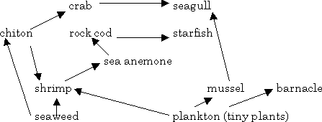

a. Write 3 food chains from this food web.

(3)

b. Write one of the good chains again in the space below and underneath each organism state which trophic level it belongs to.

(1)

c. Name 2 herbivores from this food web.

(2)

d. Name 1 producer from this food web.

(1)

2. Match up the following terms with their correct meanings. Write your answers in the boxes below.

a. habitat i. all the individuals of 1 species in an area
b. population ii. the plants and animals in an area
c. ecology iii. the place where an organism lives
d. consumer iv. the study of plants and animals in their environment
e. community v. an organism which cannot make its own food so must eat plants or animals.

a |  | b |  | c |  | d |  | e

3. Write down 2 adaptations that a bird has and explain how these adaptations help the bird to survive.

(4)

4. Write down 2 adaptations that a caterpillar has and after each adaptation state whether it is structural, behavioural or physiological.

(4)

Total = 20 marks

