The Garden Party
Actions Showing Character

What techniques and methods does the writer use to draw the reader's attention to the personality (character traits) of the characters in the story?

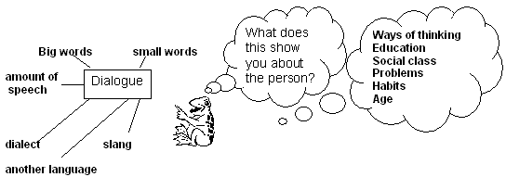

Dialogue (Conversation) | Mrs Sheridan What does this show us about the person?
Speech is grammatically correct  Semi-formal speech not casual  Some sentences are quite complex  Cultured and polite | Shows authority as a mother and manager of the household  Educated and therefore suggests a middle class upbringing

Repeated key words

Words repeated | What does this show you about the person?
“My dear child…” | Condescending. Indicates some degree of position in society.

Events in the story

What is the main event? | The death of a working class neighbour on the day of the garden party.

Event Task Worksheet with Answers

The character's reactions to events that occur in a story reveal a lot about their personality. By looking at what they do we can make judgements about their personality or their character traits. Complete the box below. The first one has been done for you.

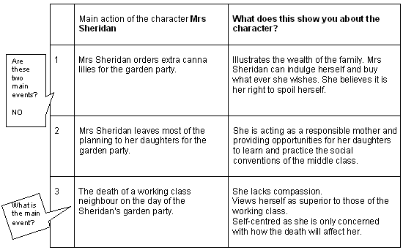

The techniques used by the writer show us Mrs Sheridan’s character?

Techniques:

* Dialogue
* Event
* Repeated key words
* Point of view – narrative
* Relationship with other characters

What does this tell us about the person?

* educated / middle class background
* unsympathetic / lacks empathy

