Our Changing World (Reading): Unit Standard 2986

The Secret Life of Estuaries
Adapted from the text ‘The Secret Life of Estuaries’ by Andrew Innes, pp18-25, in Connected, 3, 2006. Wellington: Learning Media.

Writers: Jenni Bedford and Breda Matthews

NCEA LEVEL 2
Unit Standard | Performance Criteria
Unit standard 2986, version 6  Begin to read independently texts to gain knowledge (ESOL)  Range: at least three texts, each from a separate familiar context. | 1.1 The topic of each text is identified and the content predicted from key words, layout, illustrations, and diagrams.  1.2 Main point(s) and supporting detail in each text are identified and understanding demonstrated.  1.3 Understanding is demonstrated of essential vocabulary within each text.  Range: at least ten  vocabulary items – meaning  and grammatical form.

RESOURCES
Other assessment activities for unit standard 2986:
- ‘Our Changing World’ (Reading): Cleaning up
- ‘Our Changing World’ (Reading): The Sands of St Clair

Assessment activities, for other unit standards, that could be used in conjunction with unit standard 2986:
- Listening: ‘Our Changing World’ (US15007)
- Speaking: ‘Our Changing World’ (US 17360)
- Writing: ‘Our Changing World’ (US 17368)
Teacher Sheet: Task 1

The Secret Life of Estuaries by Andrew Innes

Unit standard 2986, version 6

Begin to read independently texts to gain knowledge (ESOL)

Level 2 5 credits
This unit standard has one element:
Element 1.
Students must show that they can read at least three complete information texts, each from a separate context.
This is ONE of three reading assessments needed to complete the standard.

Conditions
- Assistance may be given to understand the requirements of the task.
- A bilingual and/or an English dictionary may be used.
- Understanding may be demonstrated by oral or written response.
- Written responses need not be grammatically correct, but errors must not interfere with meaning.

Learning context
The English Language Intensive Programme (ELIP) Stage 2, has suggested teaching components, strategies, language features and sample texts on information report genre: ‘Kiwi’ (5c); ‘Sharks’ (5d); ‘Kangaroos’ (11c); ‘Antarctica’ (11d); ‘New Zealand’ (20c) and ‘Drugs’ (20d).

Notes for Assessors
- It is important to be aware of the special notes in the standard.
- Each of the three texts should be assessed at a different time as part of a wider area of study.
- This assessment activity should follow class activities in which the students have had the opportunity to become familiar with the topic through a range of listening, speaking, reading and writing activities. The context and vocabulary should be familiar to the students.
- The question types should also be familiar to the students and this can be achieved by including similar question types in the formative work.
- Students should not have seen the text before the assessment activity.
- If resubmission takes place, the assessor should ensure that the correct answers are not inadvertently indicated when scripts are returned. For example, in a true or false exercise it would be inappropriate to indicate which ones were correct on the student’s script.
- Question 1 is a prediction exercise that must be completed before the students see the text. It cannot therefore be resubmitted once students have read the complete text.

Student Sheet: Task 1

Unit standard 2986, version 6
Begin to read independently texts to gain knowledge (ESOL)

Level 2 5 Credits
Name: ______________________________

Date: _______________________________

- Do this activity in class.
- You may ask the teacher to explain the instructions.
- You may use a bilingual and or an English dictionary but not an electronic translator.
- Your spelling and grammar do not need to be perfect but your teacher needs to be able to understand what you mean.

Student checklist: Task 1

In this assessment task you will need to show that you can do the following things. |  | ✓/✗
1.1 | Identify the topic of the text and predict the content of the text from key words, layout, illustrations and diagrams.
1.2 | Identify the main point(s) and supporting detail in the text and understand what they mean.
1.3 | Understand the important vocabulary in the text – the meaning and grammatical form of 10 words.

Text for Question 1a and b

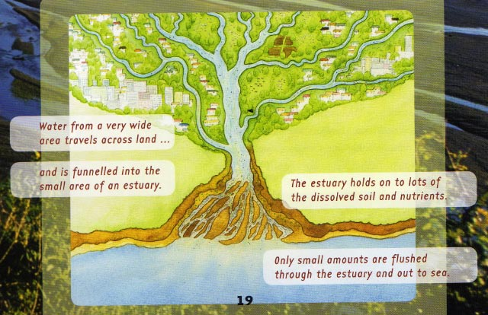

On the Move

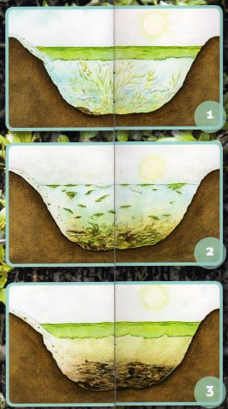

Keeping the estuary clean

When good nutrients go bad

Healthy harbours and food chains

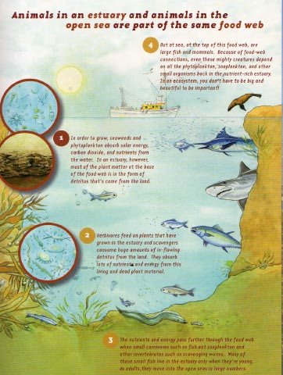

Student sheet: Task 1

Assessment for unit standard 2986, version 6
Begin to read independently texts to gain information (ESOL)
Level 2 5 credits

Name ……………………………………………………... Date ………………

1. Identifying the topic of the text and predicting the content (1.1).

Look at the key words, layout, illustrations and diagrams in the text for Questions 1a and 1b.

1. What do you think this text will be about?

I think this text will be about

a.

and might have information about

b.
i)
ii)
iii)

When you have finished, give this first page to your teacher so that you can receive the rest of the assessment.

‘The Secret Life of Estuaries’
Adapted from ‘The Secret Life of Estuaries’ by Andrew Innes (in Connected 3, 2006, Learning Media, Wellington).

On the move

Estuaries are those parts of a bay or harbour where fresh water and sea water meet. Fresh water moves over land or travels down rivers and streams to the sea and the tide brings sea water into the estuary twice every day.

Keeping the estuary clean

The plants and animals that live in the estuary help to recycle nutrients and detritus (rotting plants and animals). The fresh water brings soil, nutrients and detritus. Lugworms, crabs and filter feeders like cockles digest the nutrients. Bacteria digest the detritus and some nutrients. When the tide comes in it cleans out the estuary twice a day.

When good nutrients go bad

If there are too many nutrients in the estuary the food chain breaks down. Too many nutrients cause water plants to grow out of control. When the weather cools, these plants die and sink to the bottom where they are digested by aerobic bacteria. However, because there is such a lot of detritus, the bacteria use up all of the oxygen in the water. If this happens the bacteria and lots of animals living in the water die and the food chain is broken.

Healthy harbours and food chains

A healthy harbour has a healthy food chain. The first part of a food chain is always a plant. In an estuary this is usually the detritus (rotting plants) that the fresh water brings to the estuary. Zooplankton, worms and other herbivores eat living plants and detritus. Small carnivores such as shrimps and fish eat the herbivores. Next in the food chain are large fish which are then eaten by even larger fish, seabirds and mammals, such as seals and people. There is a lot of eating going on in the sea.

294 words
Student sheet: Task 1

Assessment for unit standard 2986, version 6
Begin to read independently texts to gain information (ESOL)
Level 2 5 credits

Name ……………………………………………………... Date …………………

Task 1. Now read the text and answer the questions below.

2. Identify main points and supporting detail (1.2).

2a. Complete the chart on the next page. Choose from these main ideas and
supporting details.

Choose from these main ideas and supporting details

a) lugworms
b) Next herbivores such as zooplankton, worms and other herbivores eat living plants and detritus.
c) cockles
d) If there are too many nutrients the food chain breaks down.
e) Finally larger carnivores, seabirds and mammals, eat the small carnivores.
f) Then small carnivores such as fish and shrimps eat the herbivores.
g) Estuaries are where fresh water and sea water meet.
h) Finally the bacteria and other living things die.

Write the main ideas and supporting details from the list on the previous page in the spaces below. Think carefully about where each one goes.
Main idea | Supporting detail
i) | The fresh water travels over land or down rivers and streams.  The tide brings sea water in twice a day.
Lots of plants and animals recycle nutrients and detritus. | - bacteria  - ii)  - crabs  - iii)
iv) | First the plants grow out of control.  Next the weather cools down and the plants die and sink to the bottom of the estuary.  There they are digested by aerobic bacteria.  Eventually the bacteria use up all the oxygen.  v)
A healthy harbour has a healthy food chain. | The first thing is a plant or detritus.  vi)  vii)  viii)

3. Understanding is demonstrated of essential vocabulary in the text (1.3)

3a. Meaning - Match the words with their meaning in this text. Choose from the list of words in the box. Be careful that you choose the meaning in this text as some words have more than one meaning.

Words

to rot  the tide  a food chain | to recycle  to sink  soil | a bay  to digest  nutrients | bacteria  healthy  a carnivore

Word | Meanings
i | to use something more than once
ii | the feeding relationships between living things
iii | a curved part of the coast
iv | in good condition
v | to go bad or decay
vi | to go under the water
vii | earth
viii | the regular rise and fall of the sea level
ix | something that is food for plants or animals
x | to eat and use food
xi | an animal that eats other animals
xii | very small living things, you need a microscope to see them

3b. Grammatical form

Choose the correct grammatical form of the word from the choices given in brackets to fit the sentence.

Estuaries are found in (i) ……………. (bay, bays) and harbours.

It is important to keep our estuaries (ii) . ……………….. (health, healthy)

The (iii) ………………. (tide, tides) cleans the estuary twice a day.

The (iv) ………………… (soil, soils) in estuaries contains nutrients.

The estuary plants and animals need (v) ……………….. (nutrient, nutrients) to live.

The plants and animals (vi) ………………… (recycle, recycles, recycling) many of the things in the estuary.

In cold weather the plants die and (vii) ……………. (sinks, sink, sank) to the bottom of the estuary.

On the bottom of the estuary the dead plants (viii) ……………. (rotting, rotten, rot).

Then aerobic bacteria (ix) …………… ……(digest, digested, digesting) the detritus.

If there is too much detritus the (x) …………………….(bacteria, bacterium) may use up all of the oxygen.

In healthy harbours and estuaries there are healthy (xi) ………………………. (food chain, food chains)

The last animals in the estuary food chain are large (xii) ……………………… (carnivorous, carnivores, carnivore).

Assessment schedule: Task 1 - The secret life of estuaries

Unit standard 2896, version 6
Begin to read independently texts to gain knowledge (ESOL)
Level 2 5 credits
Element 1: This task assesses one of three texts.
PC | Question | Evidence | Judgement
1.1 | 1 | Answers show that key words, layout, illustrations and diagrams have been used to predict the topic and possible content.  Answers similar to:  1a) Estuaries/ harbours/ bays  1b) Cleaning estuaries/ harbours/ clean water/ pollution/ food chains/webs  Allow for culturally different but possible answers e.g. learners from other countries might produce answers focusing on knowledge of estuaries as places to be avoided or bad places to collect food. | Topic is identified and content predicted from key words, layout, illustrations and diagrams  1a) Any reasonable prediction  1b) 2 out of 3 must be reasonable predictions
1.2 | 2 | i. g) - Estuaries are where fresh water and sea water meet.  Ii a) lugworms or c) cockles  iii. a) lugworms or c) cockles  iv. d) If there are too many nutrients the food chain breaks down.  v. h) Finally the bacteria and other living things die.  vi. b) Next herbivores such as zooplankton / worms / herbivores eat living plants and detritus.  vii. f) Then small carnivores such as fish eat the herbivores.  viii. e) Finally larger carnivores, seabirds and mammals, eat the small carnivores. | Main points and supporting details are identified.  Understanding is demonstrated by linking main points and supporting details correctly.  6 out of 8 correct

1.3 | 3a | Correct answers are  - to recycle  - a food chain  - a bay  - healthy  - to rot  - to sink  - soil  - the tide  - nutrients  - to digest  - a carnivore  - bacteria | Understanding of the meaning of ten items of essential vocabulary is demonstrated.  10 out of 12 correct
1.3 | 3b | Correct answers are  - bays  - healthy  - tide  - soil  - nutrients  - recycle  - sink  - rot  - digest  - bacteria  - food chains  - carnivores | Understanding of the grammatical form of ten items essential vocabulary is demonstrated.  10 out of 12 correct

